# 

# 

# Applied Project and Minor Dissertation

**Final Year Project**

**B.Sc.(Hons) in Software Development**

**By**

**James Nelly**

**Brendan Toolan**

**Advised by Mark Campbell & Brian McGinley**

Department of Computer Science and Applied Physics Galway-Mayo Institute of Technology (GMIT)

Table of Contents

**Applied Project and Minor Dissertation** **0**

**1.0 Introduction** **4**

1 The Idea 5

1.2 Formulating the solution 5

1.3 Why there is a need for this website 6

1.4 Level 8 project 6

1.5 Chapter Descriptions 7

**2.0 Methodology** **9**

2.1 Overview 9

2.2 Idea 10

2.3 Research 10

2.4 Initial Development 12

2.5 Weekly Meetings 13

2.6 Integration and Testing 13

2.7 Functionally and Testing 15

2.8 Cleanup and Dissertation 15

2.9 Testing 16

2.9.1 Unit Testing 16

2.9.2 System Testing 16

2.9.3 Regression Testing 16

**3.0 Technology Review** **17**

3.1 History of booking systems 17

3.2 The Angular Framework 17

3.2.1 Background on Angular 17

3.2.2 Why we used the Angular Framework 18

3.3 Using components from angular in our project 18

3.4 Using Routing from angular in our project 19

3.5 Using Services from angular in our project 20

3.6 Languages used in our project 21

3.6.1 Typescript 21

3.6.2 Javascript 21

3.6.3 HTML 22

3.6.4 CSS 22

3.7 Using MySQL database for our project 23

3.7.1 Background on MySQL 23

3.7.2 Why we used MySQL 23

3.7.2 Our MySql setup 23

3.8 Using Express server for our project 24

3.8.1 Background on Node express 24

3.8.2 Why we used Node Express 24

3.8.3 Packages installed for Node.js for project 24

3.9 Using Aws cloud for our project 26

3.9.2 Background on Aws 26

3.9.3 Why we used Aws 27

3.9.4 Our AWS setup 27

3.10 Using Postman for our project 28

3.10.2 Background on Postman 28

3.10.3 Why we used Postman 29

**4.0 System Design** **29**

4.1 System Architecture 29

4.2 UML Diagram 31

4.2.1 Register and Login Components 31

4.2.2 Location Component 39

4.2.3 Instructor Component 41

4.2.4 Instructor-Details Component 42

4.2.5 Booking Component 43

4.2.6 Booking-details Component 46

4.2.7 Booking-update Component 47

4.2.8 Api.service 49

4.2.9 Api.js file 50

4.2.10 Server.js file 51

4.2.11 Header and Footer components 52

4.2.13 Config.js 54

4.3 Flowchart Diagram of the booking workflow 56

4.4 Flowchart Diagram of the Register/Login workflow 57

**5.0 System Evaluation** **58**

5.1 Testing methods in server 58

5.1.2 Post Request testing using Postman 59

5.1.3 Delete Request testing using Postman 60

5.2 Users testing the Application 60

5.2.1 Data taken from testing 61

5.2.2 Instructor A Feedback 62

5.2.3 Instructor B Feedback 62

5.3 testing the Website on different Browsers 63

5.4 Limitations and Problems we came across 64

**6.0 Conclusion** **67**

6.1 Conclusion 67

6.2 Goals and Objectives 67

6.3 Final reflections of the Project 68

**7.0 Appendices** **70**

7.1 Installation Guide 70

**8.0 References** **72**

# 1.0 Introduction

This is the introduction section of our documentation of our Applied Project and Minor Dissertation project.. For our final year project we both decided to work together and do a joint project for this module. We are doing a web based application that will allow people in the general Galway area to be able to book a driving lesson with an instructor online. The user will be able to register with the website and input their details to sign up. The details that the user will be required to input will be their First name, Last Name, Email address and also to set a password for their account. Once the user has logged in correctly after signing up, they will be brought straight to the locations page of the website where they are able to select on the various locations in the Galway area based on their own location, from there a list of instructors who are in that area will pop up and there information is displayed like there name and email address and phone number. On this page you will be given the option to make a booking with the instructor or delete a booking. (**Adding a booking)**. When making a booking the user will have to pick a date and time for their booking also they can give the booking a title like “first lesson” or “second” etc. **(Delete a booking)**. Once the user has clicked on the delete button they will be able to find the booking they made earlier and delete it with ease. All they have to do is click on the booking and click on the delete option. Also have the other option of editing the booking only if you had made one beforehand. Once you click on the add edit option you will then be able to change the time and date that you would like to book and also the title if you want. Also there will be an option in the header of the web page to logout of your account after you have completed the action that the user wanted to do. Another bit of functionality we have added is the confirmation by Email for the booking you have added and also when you have cancelled a booking. Once the user has finished their booking they can then logout of the website. Our project will consist of a couple of elements, the framework we will be using is Angular the database which we have chosen is MySQL the server we are using is node and we intend to implement this on the cloud. For the cloud service we will be using Google cloud.

## 1 The Idea

When coming up with ideas for the project we were going to do for our dissertation, at the same time the two of us were in the middle of completing our driving lessons and had our driving tests booked. We both came up with the idea that there was no real platform or website that we could go onto and book our local driving instructor. At this time the only way to get contact with a driving instructor was either to hopefully get their contact details of someone who had got their lessons off them or if you were lucky they may have a facebook page. We felt that this method of trying to find an instructor was not efficient. We then came up with the idea that we would make a website where you could book an instructor within your area of Galway. You could search through all the different locations and find the location nearest to you, and then you could then find an instructor in that location and book, cancel or edit the booking that you have made. Also the user would be able to make an account to register for the website, provide their details to register and that it would be easier to track the various bookings on the website once they had logged in.

## 1.2 Formulating the solution

When we came to the design of the solution, James got in contact with some of the instructors and asked some questions about how they do their process of booking people for their lesson, and how they slot them in for the week ahead and making everything go as smoothly as possible. Some of the questions I asked were how to handle bookings if you have a busy schedule, also what if there is a cancellation how do you deal with this. Also on how payment is carried out for the booking.At this moment in time none of the instructors that James asked did not have a system or website to carry out the functions they need to book customer’s for lessons. Many of the instructors were using the old fashioned way of keeping the booking’s in their diary and using it as their scheduler. They would take a phone call from a customer and give the customer a date which suited them for the lesson and would take their name and phone number. Most of the instructors had a rule of where they would like to have a day or two notice if the customer wanted to cancel or change the booking to a different or later date

## 1.3 Why there is a need for this website

When we were doing research for the project we wanted to know the number of people who were doing their driving test yearly, we wanted to know the statistics. We found some interesting numbers on the Central statistics office website which gave us most of the information that we wanted. We noticed over the last few years there has been a steady increase of people applying to do their driving test.

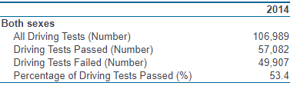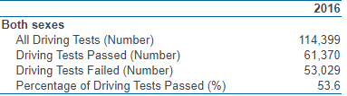

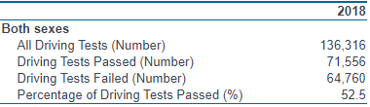

With these numbers we could see that the number of people taking the test increased quite a lot. Which led us to believe that there is such a need for a website/platform. This website could facilitate many people who need to book their instructors in an easy and efficient way. These numbers could easily hit 150,000 by the year 2020. The app would also be useful for the driving instructors, as the app would keep information and then remind them of any appointments that have been made through the app.**[23]**

## 1.4 Level 8 project

We believe this project that we will be undertaking will test our skills as there are quite a few elements that need to be developed in order to have the project up and running at the acquired level. To facilitate some of the elements will be split between the two of us, we came to an agreement that James Nelly would be undertaking the angular development the various functions need to be designed like the connection between server (backend) and the mysql database, and also the various get post and delete methods that are needed for the website. James would also be undertaking the task of setting up the cloud services for the website.This will be carried out on Google Cloud. In the last few years we have developed different applications whether it be a CRUD **(Create, read, update and delete)** application web application or a game application. We believe we have acquired the skills to tackle the problem we have created, and that we will build a viable solution. Brendan would take on the task of creating a register and login system for the project. This will let the user register with the web page. The user will be required to put in their name, surname, address, phone number, email and then create a password for the account. Once done the user can log into their accounts by entering their email and password. The login is made to recognize any existing users. If someone who had registered before logs in, then it should return an error saying that its an invalid email or password. The user information will then be sent to the database. Brendan researched online on how this could be done. From online Brendan found out that the use of JWT( JSON Web Tokens)would be suited for this as there was much documentation available on how to make them work with angular. A JSON Web Token is commonly used for authorization and is an efficient way of securely transferring information between two parties.

## 1.5 Chapter Descriptions

**Methodology**

In this chapter of the documentation we will discuss the methodology that we used in the development of our project and how it has aided us in the development process. The methodology we used was agile, it helped us to increment development on a weekly basis and to keep workflow moving consistently. Also it will mention the different development tools we used to collaborate and develop the project and also the way in which we stayed in contact to deliver the project

**Technology Review**

In this chapter of the documentation we will discuss the different technologies we used for the development of our project, and we will explain why we choose these technologies for our project. We will be describing how these different technologies played a role in the development of the project and how they worked together.

**System Design**

In this section of the documentation we will discuss the architecture of the project, we also will be discussing the research that went into the construction of the project. We will be discussing how all the elements interact with one another. Also there will be different diagrams exlaing the different components and the general layout of the project. The will also be diagrams describing the workflow through the different elements aon how to make a booking and making an account and logging with the application

**System Evaluation**

In this section of the documentation we will discuss how we tested out our project to see if we can find any limitations and to see how robust or website is. We will discuss some of the ways we went about testing our project. Tables and graphs will be provided for visual results of our completed testing.

**Conclusion**

In this chapter of the documentation we will discuss the conclusion of our project, we will discuss the outcomes of the project. We will reflect on the various problems we came across and the solutions that came with them and also the knowledge we have gained from doing the project.

# 

# 2.0 Methodology

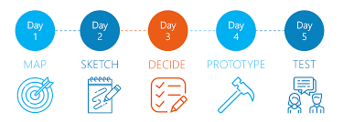

## 2.1 Overview

In this section we will discuss the approach to the development of the project, describe the methodology that was used and how we implemented it and also talk about how the development of the project progressed in the end. At the end of this chapter the reader should be able to have a good impression of the scale of the project and the necessary steps that were taken throughout the project. For our final year project we both wanted to use a constant design process to which changes and issues could be kept accounted for and so that we would be able to deal with them when they happened in an easy and dynamic way. As a result we decided to use the Agile method would be the best fit for us as we had both had experience and knowledge of it from our previous years from the course. The Agile methodology is a certain approach to the management of a project which is greatly suited to us doing any project in Software Development. In using this method it will help us to come up against any problems or difficulties such as code errors, changing the format of the project so as to suit the clients demands etc. Agile uses work sequences that are called ‘Sprints’ which is a course of time that’s designated for certain stages in the development of a project. When creating a project, time is an important factor especially when one does Software Development so the idea of using Sprints is very important.

Something that we both liked about the Agile Methodology is “Stand Ups''. This term is used to describe daily meetings about the progress of the development of a project. **[27]** Seeing that both of us were in the same course we would be able to communicate with each other face to face during our breaks and lunch breaks. We also did this with our supervisors but instead of daily meetings we limited our time with them to once a week as they were not able to meet us on a daily basis due to their schedules. We used these meetings as a way to discuss the progress of the project and as a way to make sure that we were individually keeping on top of the development of the project and to see if as a group that we were able to solve any problems that we might have. And also was a very good technique to keep all informed.

## 2.2 Idea

Before we decided on what the project would be both James and Brendan were assigned a different super-advisor each so they both had separate ideas before coming up with the end product. James and Brendan decided to do a joint project together so as to split the workload between the two. We discussed potential ideas for what we can do for our final year project, and examined what problems that we could come across during the development of the project and how we could be able to solve said problem and the manner we would do so. We also researched what programming languages that would be best suited for us to use and what technology that can be applied to us.

Brendan's first idea for the project was to do an application that would help people cut down on smoking as he saw that a lot of college students smoked and thought that an application as such could help. James had come up with the idea of an application/or website that restaurants/hotels could be able to order food and kitchen supplies from. However we both were unhappy with our initial ideas as we could not see how we would be able to make them stand out. In the end we decided that the project would be an application/website that would let people book driving lessons from certain driving instructors in the Galway area.

Once we had the idea of what our final year project sorted out we both went into the next stage which is the research phase.

## 2.3 Research

The next stage focused on us going through and researching what would be best needed for the project, i.e. what programming language to use, what program to use and see if there are any external libraries or resources that could be used to help us improve the general scope of the project.

The types of research that we undertook ranged from going online, reading articles, videos on YouTube, forum posts on the website Stack Overflow and as well as peer-to-peer asking our fellow students about their how they felt using certain programming languages in the past and experiences with programs. We also used our time that we met with our supervisor's to ask them their opinions on the subject. We also took advantage of the library in GMIT to go through the books that may be of help to us in the development of the project.

We decided that the best way to develop the project was to use the program ‘Visual Studio Code’. We both had experience in using this program from previous years in college and is multi-platform for both Windows and Linux users. And almost any programming language could be used on it such as Flask, JavaScript and Typescript. It also has a built-in terminal available to users.

We looked into programming languages we could use for the development. We both had agreed to be open to using a programming language that we had never used before so we could be able to learn a new language along the way. We made a list of languages that we could potentially use in the development. For this we had booked rooms in the GMIT library so as we could go through documentation of various programming languages and see the pros and cons of each language. Here we created for ourselves a mind map so we could get a greater scope and understanding of what we both wanted for the project and go about to developing it

**Mind Map**

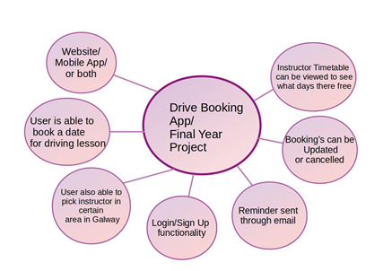

We made the decision to use Python Flask as we started to use it in another module during this time. However this was later changed into using Angular and node instead as we had experience with it and there was much documentation on it available for us to use. It also seemed to be better suited for the development of the project seeing as we wanted a back-end and front-end for the project.

We also looked into what we could use as a database so as to store information.**[8]** We decided to use MySQL, an open source relational database management system that’s open source and free. We also were taught about MySQL the year before so we both have some know-how on it.

## 2.4 Initial Development

First off we had set up a Github repository that we could store, push and pull the code during the development of the project. When we decided on a framework that we were both happy with we moved onto the groundwork of the project. To stop the problem of version control we used Github that both of us have considerable experience in using it for past projects. Both of us were then added as collaborators so that we both could work on the project seeing that we live in separate parts of the country.

We then sorted the layout of the files and folders for the project so it would be easy for us to navigate through Visual Code by separating the back-end from the front-end by placing all the code and files that will be needed for the front-end and another folder to place the back-end code. We first started to test out a mock demo version of displaying a database when you ran the project at first and from there it gradually became more and more of what we inversion for the project.

During this time or Sprint both James and Brendan would meet up on Thursday in a booked library room in GMIT so that we could begin having sessions where the two of us would review each other's code. We did so that it would help us get the development done faster, and to get the other person views and thoughts on the code and see if the other would be able to solve any problems that one of us might have. We also did this so that we both would have something to show to our supervisors the week next and to keep on track of the project.

An primary issue that we had was setting the MySQL database on Brendan’s laptop as Brendan had changed his operating system from windows to linux during the semester. The issue was that Brendan could not seem to get the MySQL database to run on his laptop. This meant that Brendan could not work on the project. The issue was resolved when Brendan and James met up on a Friday during which neither two had any classes on that day so as to work together to solve this and also we got advice and help from our fellow peers who had similar problems in the past.

## 2.5 Weekly Meetings

Each week during the development and thought process of our final year project both Brendan and James attended weekly meetings with their supervisors at certain days and times that suited both parties. During the first semester We all had agreed that one week that both James and Brendan would meet up with Brendan's initial supervisor Mark Campbell at 2pm in prefab 18 on the GMIT campus and then the following week the two would then meet up with Brian McGinley James initial supervisor on a Tuesday at 1pm. This arrangement would continue during the first semester where we would meet one of the supervisor’s a week. Once the second semester began, time was more flexible for all four people to meet all together. We arranged that we would meet every Monday at 2pm in the canteen. As a result of the Covid-19 Pandemic, GMIT had to close campus for students and staff for the health and safety of those people. However through the use of Microsoft teams we could still have our weekly meetings online from our homes. The purpose of these meetings were so that we could chart the progress that we were making with the project with our supervisors. This was also time that we could get feedback from our supervisors to see what direction we can go with the project, their opinion on the progress we had made from the week before and check in with them to see if they would be able to help us with any errors that we might be having with the project. After each of these meetings we would then email both supervisors a summary of what was discussed in the meeting and what we would try to get achieved for the next meeting.

## 2.6 Integration and Testing

The next stage or sprint was to focus on the integration and the testing of the platforms and technologies that we had chosen to use. We first tested to see how we would set up a database for the project as we would need it to give data to the database and then also read from the same database. We set up the database locally at first as we had to make sure that we could do what we wanted with it before we set it up on AWS cloud. We set up the database with mock variables inside each table first to see if the application would be able to recognise it.

**Mock variables stored in the booking table in the MySQL Database**

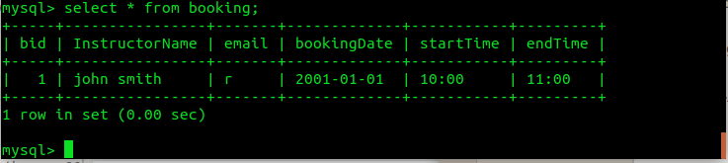

**Mock variables being read into the project from the database**

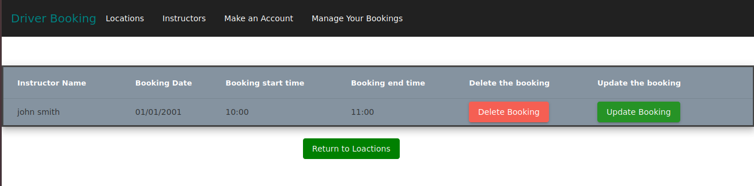

Once we saw that our application was able to read from the database and we then went onto to test to see if the AWS cloud would also be able to work with our application.

We then went to see if we were able to log in into the website with the test username and password data that was set up when first creating the users table in the MySQL database. The first test we did with the login page was to check to see if the site was able to return an error if the username or password did not match. This was checked by intentionally entering a wrong username and/or an incorrect password. Then the next step was to check to see if the entered the right details would return true in the console by typing in the test data that we had initialised in the database beforehand.

Another aspect of testing we had done during the development of the project was to check to see which framework and programming languages that we would use for our final year project. At first we tested out using Flask as mentioned before in this dissertation. After doing trial test with the language we saw that we could of being able to achieve what we set out for our final year project as despite the documentation that was available for Flask online we concluded that we did not have much experience with the language, so we decided to use angular**[10]** because we had used in college modules the years previous.

When setting up Visual Code there was an update available in November. When we both saw this we took the time one of the days during one of our one hour breaks in college to review the features of the update to see if we would be beneficial for us during the development of the project. These features include editing both files in a different editor, folder can be compacted in the explorer, the ability to extract an inline type to a Typeface interface etc. **[****26****]** Although we saw that these update features were pretty good but we decided against it as we found that the version of the Visual Code we had on our respective machines was already well suited for the project's development and thought we best avoid this incase that we come across any errors we may come across when it gets updated.

## 2.7 Functionally and Testing

The next sprint was solely to concentrate on the gist of the project, where we sort out the layout and hierarchy of the project as in what goes into the backend and what goes into the frontend, and the issues where we came across. These issues can be read in more detail in the conclusion section of this dissertation.

During this time we had set up a final meeting where we reviewed our code, adding elements which we both felt were crucial so we could best explain our project and what the project should do. This was also time to add more code to the project and add CSS styling to the final product so we could make it look good as well as make it function well too. Also during this we both took notes of where the project might not have been up to scratch and what we couldn’t achieve with the project due to the Covid-19 pandemic, and added any issues that may have still existed before we went on to the final sprint.

## 2.8 Cleanup and Dissertation

The last sprint was where we both focused on cleaning up the project and also to work on writing up on our dissertation. We spent all this time implementing the research we did and applied it to the dissertation and as well images, graphs, etc that were relevant to the approach we have taken.

## 2.9 Testing

## **2.9.1 Unit Testing**

Unit Testing in Software Development is when single units or factors of a software that are tested. The purpose of this is to confirm that each unit of the software does what it is designed to do. We practiced unit testing in the early days of the development when we did the code for various aspects of the coding such as the login/register pages, the make a booking page etc.

## **2.9.2 System Testing**

System Testing is where a finished and integrated software is tested. The goal of this test is to check out how the project meets with the requirements that we had set out for it. We applied this form of testing to the late/closing point of the Angular and Cloud development of the project as we decided that we had all the fundamentals bits that were important for this aspect of the project. We tested how the project was able to read from the database and and also to add, update or delete from the mySQL database we had set up that is connected to the project.

## **2.9.3 Regression Testing**

Regression Testing is a form of testing in the development of software that is designed to make sure that changes such as improvements or fixes to any defects to the software have not greatly affected the project. We both applied this testing to the latter points in the development stages of the application, when we had set up the database and set up the environment of the project. This allowed us to make any changes that would have been needed to the coding and would not impact the functionally of the project to any extent.

# 

# 

# 

# 

# 3.0 Technology Review

## 3.1 History of booking systems

The idea of booking systems first came about in the 1960’s, when IBM **(International Business Machines)** developed a system called Sabre. This system could handle reservations and the seat inventory. The system was developed for American Airlines. This system was developed as there was an influx of people wanting to travel, before this system was developed the system that was in place before hand was very labour intensive, the booking operator could be on the phone with the customer for one hour and thirty minutes, this operation took a very considerable amount of time and was not effective as there were a lot of demand for bookings and there was not enough booking operators to carry out these tasks. The way in which the system carried out these tasks goes as follows. The passengers' details were inputted into the system and then stored on disk storage, they were then retrieved from disk storage using a gross and a fine index, the gross index containing pointers to all American flight numbers by date, and the fine index referring to individual passengers booked on their respectable flight. [**1**]



## 3.2 The Angular Framework

## **3.2.1 Background on Angular**

Angular is a TypeScript based open-source web application framework which is being led by the Angular team at Google and by a community of different individuals and various corporations. It was released in 2016 which will make it 4 years old this September. It was released on Version 2 at this moment in time, it is on version 9 it was just released, and offers many new improvements with the framework. Some of these improvements are better debugging, improved CSS class and style binding, improved type checking and improved build errors.

## **3.2.2 Why we used the Angular Framework**

When we decided that we would use the Angular Framework we did not have long to think about it as we had used it before in previous modules. We had some knowledge on the inner workings of how an angular application would run, and also we knew that there were different components, services, modules and routing paths that would have to be used and configured for our project to take off .

## 3.3 Using components from angular in our project

Components are the basic building blocks of an angular application, there are 3 elements to a component first you have the template. The template defines the user interface containing the html. The second element is the Class contains the code for the view template, just like any other class in any other programming language, the class element contains methods and different properties for the application. The last element in the component is the decorator, the decorator adds metadata to the class to make it an Angular component. In our application we have many components that carry out different functions. The picture below is an example of the use of the component we have set up to show a list of locations. There is a method getting the locations and we have properties to store the location data and another property to the name of those locations. There is another function to to search the name of locations to filter them on the html page. **[2]**

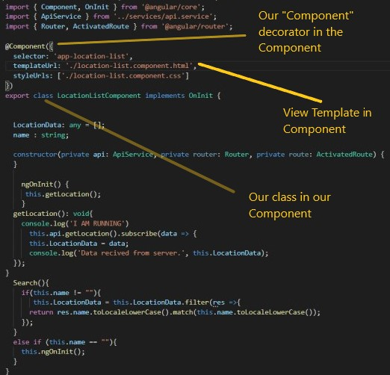

## 3.4 Using Routing from angular in our project

Routing is quite nested in our application and it's implemented in many components. Like for instance on the locations page there are links to the different locations which bring you to the various instructors that are in those location’s. Routing allows the user to navigate from one view to the next as users perform application tasks. The way I implemented routing in my application for the Location page was that I used the Location id from the database, and performed a select method in the database to get the location id of all the Instructors in the database, this function was carried out in the server. The API **(application programming interface)** then requested this data from the server. The data was then relayed back the Location logic and then displayed in html for the user. The steps to do this in the application are carried out very quickly. Another element from the routing aided this was the ActivatedRoute where in this case the data was injected into the url to display the data in the html.

The Routing was also implemented into the instructor page where the same kind of action occurred above but in the database I used the select method in Mysql to get all the instructors in that table and in turn it displays all of the data on the html. Also implemented in the navigation bar is a link to all the different pages. To navigate to them you just have to click them, but they are using the routing module and the directive that is being used is the RouterLink, it is used to link the various routes to one another. Another advantage of using RouterLink is that the page will not lose its state. [3]

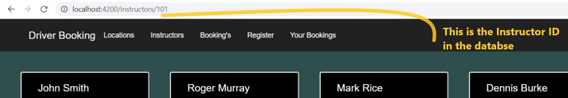

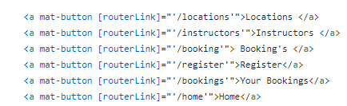

## 3.5 Using Services from angular in our project

The Service component is widely used in our project. We have two main service classes, the Api class and the Auth class. The angular service is a stateless object and it also provides very useful functions. The functions can be invoked from any component that has been setup correctly. The Api Service that I have setup is in contact with the server and carries out various CRUD operations that are needed in our project. Another module that is needed to make this work is the HttpClientModule. This module offers a simplified client HTTP **(Hypertext Transfer Protocol)** API for Angular applications that rests on the XMLHttpRequest interface exposed by browsers. The Api service handles the data when it is connected to the aws cloud service. It is accessed through the public DNS **(Domain Name System)** assigned to the instance that was created in the aws cloud [4]

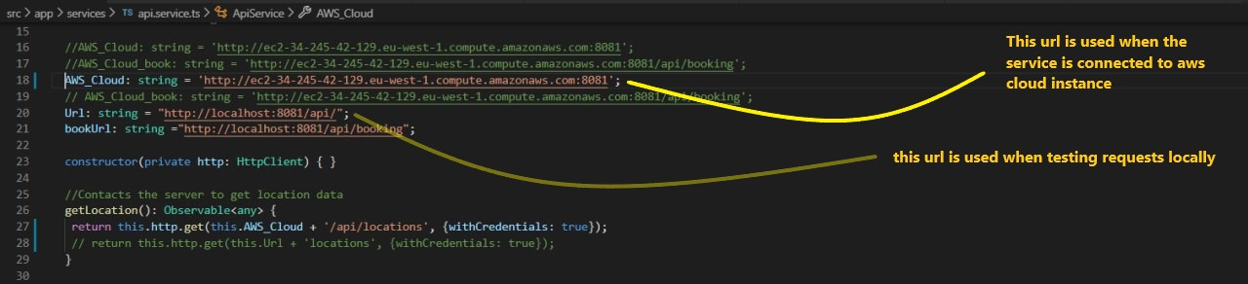

## 3.6 Languages used in our project

   

### 3.6.1 Typescript

TypeScript is a language for application-scale JavaScript. TypeScript adds optional types to JavaScript that support tools for large-scale JavaScript applications for any browser, for any host, on any type of OS. TypeScript compiles to readable, standards-based JavaScript. TypeScript is also an open-source language developed and maintained by Microsoft

**Why Typescript**

We have both used TypeScript quite a few times during our years of college and we are familiar with some of the aspects of this programming language. I found that the readability of the code was good, there is also plenty of documentation online that helped with some of my problems. [5]

### 3.6.2 Javascript

JavaScript was designed by Brendan Eich and it first appeared 24 years ago. Javascript is a client scripting language which is used for creating web pages. It has curly-bracket syntax, dynamic typing, prototype-based object-orientation, and first-class functions.

**Why Javascript**

I had Some Knowledge in using JavaScript.I used last year in one of our projects, we mainly used to develop our server. There was quite a bit of documentation on it and many resources. The development of our server was implemented with the JavaScript language. The different methods and functions used hard at first to create but once you were researching it and trying different solutions it all started to flow smoothly.

### 

### 3.6.3 HTML

Hypertext Markup Language (HTML) is the most common language used to create documents on the World Wide Web. HTML uses hundreds of different tags to define a layout for web pages. Most tags require an opening <tag> and a closing </tag>.HTML was first developed in 1990 and it was developed by WHATWG (The Web Hypertext Application Technology Working Group). This group was founded by individuals from Apple inc, Mozilla Foundation and Opera Software[17]

**Why HTML**

We have used HTML on numerous occasions during our four years of college, we have grasped many elements of this programming language and had enough understanding to use it for our project. With this programming language there is endless amounts of documentation, tutorials and resources on HTML.

### 3.6.4 CSS

CSS is a language used to describe the presentation of Web pages. With CSS you can change colors, the font and the general layout of the web page. Also with CSS you can adapt the one web page to many devices whether they have a small screen or a larger one. The initial release of the language was in 1996. It was developed byHåkon Wium Lie; Bert Bos; World Wide Web Consortium. CSS is the cornerstone language of the World Wide Web.[18]

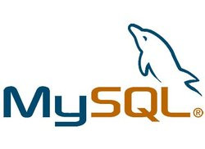

## 3.7 Using MySQL database for our project

## **3.7.1 Background on MySQL**

MySQL is an open-source relational database management system. It was developed by tye Oracle corporation and it was first released in 1995. It was written in the C programming and C++ programming language.[19]

## **3.7.2 Why we used MySQL**

We had worked with various databases through our years in college. In one module we used Neo4J database and also in this module we used MySQL, in this module we got a flavour for those 2 separate databases. In another module we worked with MongoDB and we touched upon this but did not go into great detail with it. Then in our 3rd year we had a database module which was mainly focused on the MySQL database. We gain more knowledge and understanding of the workings of the mysql database that is why we decided to choose this database for our project. Also there is lots of documentation on the web. This came in useful as it solved most of our problems when we had to connect it up with express server

## **3.7.2 Our MySql setup**

The database we created there are four tables, the first table is the locations table which holds the information of the different locations in the Galway area of the number of instructors in those locations and each location has their own Location ID and a picture of the location. The next table we created was the Instructor table that has all the data about each instructor, their name, email, phone number, the location they are situated in and also a picture of them. Our next table is the users table which stores the users who register for the website they register with their username and a password. The last table is the booking table which holds all the bookings made by the users. It stores the instructor that they have picked, the date on which the booking is, the start time of the booking and also the end time of the booking

## 

## 3.8 Using Express server for our project

## **3.8.1 Background on Node express**

Express js is a web application framework for Node js, it was released as free open source software under the MIT license. It has been designed for building web applications and API’s. It was released nine years ago and it was developed by TJ Holowaychuk and StrongLoop.

## **3.8.2 Why we used Node Express**

At first, we used Flask as our Web Development Framework, it did not work out as I was not familiar with its syntax, as it is very python based. I felt there would be a difficult learning curve to try and get familiar with, so I came to the decision that we needed to change the framework. I then decided that we would use the express js, I had some small experience with it last year in another project, I found it to be very straight forward in the setup and the use of the various request methods like Get Create Update and Delete. For the Project we have developed now for our dissertation, we took advantage of the different packages that are offered by node js, these packages aided in the development of our server

## **3.8.3 Packages installed for Node.js for project**

* Express Package

The Express package is a minimal Node Js web application framework that provides a list of robust features that help to develop web and mobile applications.

* Body Parser Package

The Body Parser package will parse incoming request bodies in the middleware before it reaches the handlers. It parses JSON Raw Text and URL-encoded. This package is not able to handle multipart bodies, this is due to size and complexity. We used this package mostly because of json data that we were using from the MySQL database.

* MySQL Package

The MySQL package was very useful to us in the development of the project, as with this package it allowed us to be able to connect to our MySQL database. We were then able to connect to the database and interact with the various tables. Most of the interaction with the tables came in the form of Create Update Delete and Get methods.

* Nodemon Package

The Nodemon package was quite helpful when I first started implementing some requests in the server, as once you had saved the implementation you had made the server would restart and launch again. This was useful in development as you could test quickly which request implementation worked and which did not

* Cors Package

The Cors package (Cross-origin resource sharing). This allows AJAX requests to skip the same -origin policy and access resources from remote hosts. This came in very useful when we decide to setup a server on the AWS cloud

* Angular Materials Animations Package

The Angular materials offer a UI (User Interface) component library. This package helped us develop a more modern interface for our webpage, like for instance the various user input boxes and the display of different information on each of the pages and its respective layouts.

* Express Session Package

The Express Session package uses a cookie to store session id in the user’s browsers and so forth. They package was added to aid the login implementation for our users for the project

* Cookie Parser Package

Cookie Parser is a middleware which parses cookies added to the client request object.

* Bcrypt Package

The Bcrypt package we added this to our project as we realized we had not added some type of security to the project, we decided that the way we would implement some level of security this would be added to the password when a user would be making an account with us. Bcrypt would hash the password and add it to the database. Bcrypt can be also used to compare the password with the finished hashed password so the user can login no problem.[20]

## 

## 3.9 Using Aws cloud for our project

## **3.9.2 Background on Aws**

Amazon Web Services is a subsidiary of Amazon that offers on demand cloud computing platforms and several APIs to many of its customers, governments and companies. To pay for these services they offer a pay as you go service. It was founded back in 2006, its parent organization is Amazon

## **3.9.3 Why we used Aws**

In the beginning we had decided to use the google cloud to host our server and MySQL database. As I began the process of setting up the instance on google cloud and began to start downloading several packages for MySQL. The issue was with the google cloud as it did not offer a public DNS. To resolve this issue, I had to change the cloud service we were using and switched to Aws cloud service. I had Experience using Aws cloud service in another semester where we worked on databases with it. So, I knew my way around setting it up efficiently.

## **3.9.4 Our AWS setup**

When setting up the Aws cloud service I had to first make an account with them which doesn’t take too long and is very straight forward. Once the account is made, I then had to launch on instance on Aws and pick a virtual machine to use. The virtual machine I picked was a Microsoft Windows Server 2012 R2 Base also it’s a 64-bit virtual machine. When configuring the settings on the virtual machine, many of them will be set to default as I have no interest in the first few. It’s the last step when configuring the virtual machine that I care about, which is its security group. There are a couple of ports that need to be open so that we can eventually access the virtual machine from our application. The first Rule we add is for the MySQL database that we are putting up on our virtual machine, the port we range we give for MySQL is port 3306, also we set the source so that any Ip address can access it, (I did this so that myself and Brendan could access it from our home.) the next rule we added was for Http which will use TCP as its protocol and the port that is being used for this is port 80. To implement some security later I also added a rule for Https and gave it the port number of 443. All these rules have a source of any which basically means that anyone can access it.

**The Rules**

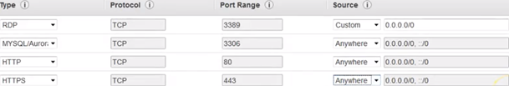

Once all the rules have been applied, I then launched the instance. Once it launched, I had to install WampServer on my virtual machine and had to install some updates for wamp so that I could get my WampServer up and running. The next step I had to do was to configure wamp this entailed in accessing a file in apache which is in wamp. In this file I had to change the workings of wamp so that we can grant access to all incoming requests before it would have blocked them. The Final step I had to make was to allow any requests made on the ports that were made in the rules. This had to be done in VM in the firewall settings where the Inbound rules are created. Once this step was completed, I had to check if I had done it correctly. All I had to do was copy the Ip address that was assigned to the VM that I created, and go back to my local machine and paste the Ip address into the browser and if the page displayed my WampServer running from my VM, I then know that all the steps were carried out correctly.[21]



## 3.10 Using Postman for our project

## **3.10.2 Background on Postman**

Postman is an Api client that makes it easy for a programmer to create, share, test and document Api. The user can easily make Http/s requests and can also read their response. It’s a more systematic approach to testing and it doesn’t take up too much time. Postman was founded in 2014.

## **3.10.3 Why we used Postman**

We used postman for one main reason and that was to test if our Api requests and responses were working as intended. Postman comes with many various options in the way you want to test those api calls. There is the option of a post method Delete, Get, put these were the api calls that I implemented, postman offers quite a lot more. There are also many options to test your requests and responses with different types of data that is being used to be sent and received through api calls. The data that we used to carry out these api calls was always json data that was either being sent into the MySQL DB was being retrieved from the DB or else it was being deleted from the DB. To add I had used Postman many times before in other projects which had some element of an api request or response integrated into it.**[22]**

# 4.0 System Design

## **4.1 System Architecture**

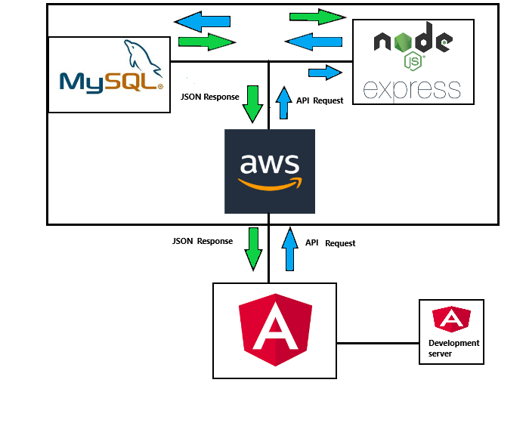

* MySql - Database that is needed for the project so the server can send and read data from it. This data ranges from the locations in the area, the driving instructors, details of any bookings that have been made and the information of the users.
* Node / Express - The server that is used to read the data and set the various API’s such as the locations, instructors, and the login/register for the users that are used in the project.
* AWS Cloud - This is used so that we both are able to add, update, delete or read from the database globally instead of locally.
* Angular - Platform that we used to create the project and to implement the functionally of our project so as to be able to let the user book a driving lesson, let the user login and register with the programming languages Typescript, Javascript ,etc.

## 

## 

## 

## 

## 

## 

## 

## 

## 

## 

## 

## **4.2 UML Diagram**

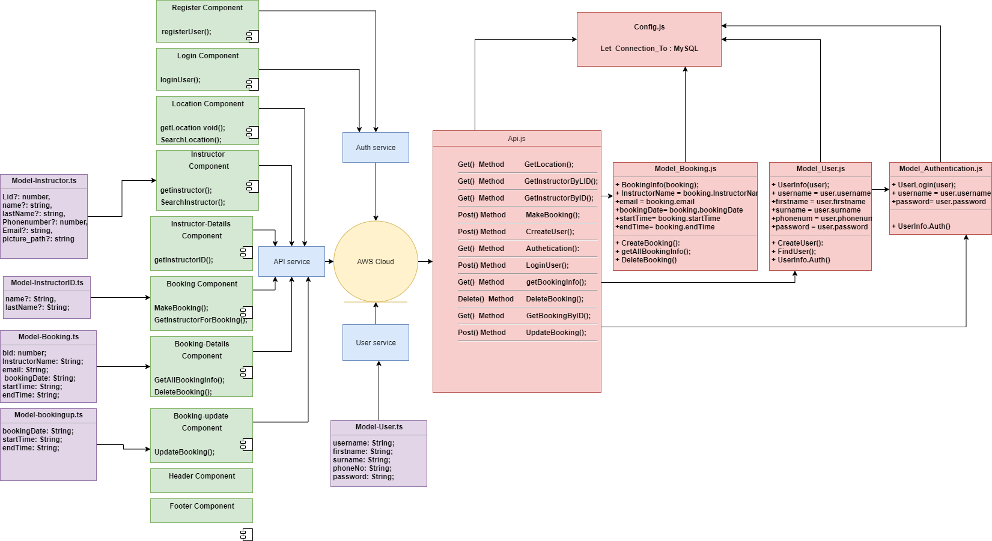

The UML diagram above shows the different components, models and services that were used to implement and connect the server and the database together. Also the presence of the virtual machine (AWS).[24]

## 

## 

## **4.2.1 Register and Login Components**

For this project we felt that it would be best suited to have both a register and login component so the project would seem like a real life application and it would seem more professional to the examiners that would be grading our project. **[12]** In order to do so, we created a table in the MySql database called ‘users’ that where the information the users enter their details can be stored into. This information being the users account name(or username), firstname, surname , phone number and password. **[9]**

**The register page in the project with the fields required**

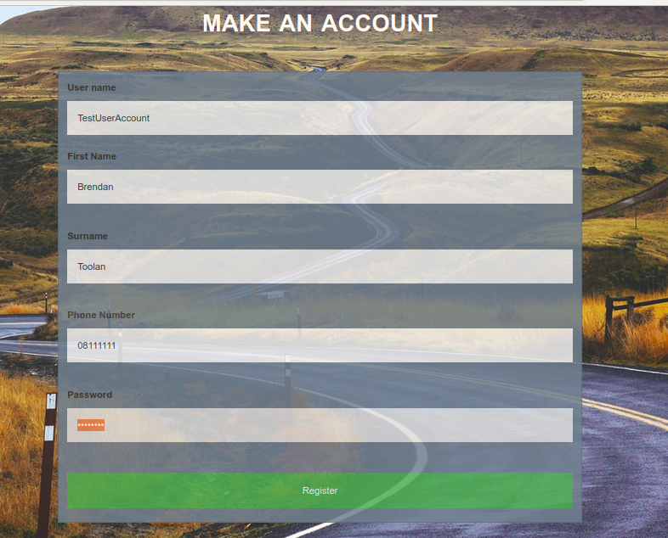

Once the user clicks on the register button below, the data that was entered then gets stored into the mysql database.

**User information being stored into the MYSQL database**

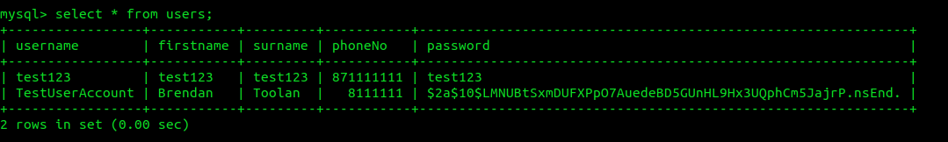

Next up was to set up the Login component of the project. The first page that will show up when a user starts up our project will be the login page where he/she/they will be required to log in with their username and also their password to get access to the rest of the application features. If the user were to put in the wrong username or password then the the project would not navigate to the instructor page but if the information entered was correct then the user would be navigated to the the instructors page.

**The login page with the username and password entered**

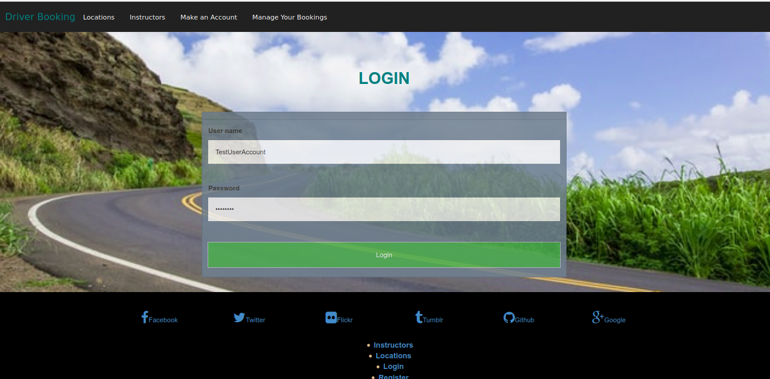

**The node express server confirming that the login data was true**

## 

This is all done creating components in the frontend for the login and the register pages. Setting up the layout of these pages was not hard to do as it was just basic html code. However the main functionally from these pages from their respective typescript files and also from the backend of the project.

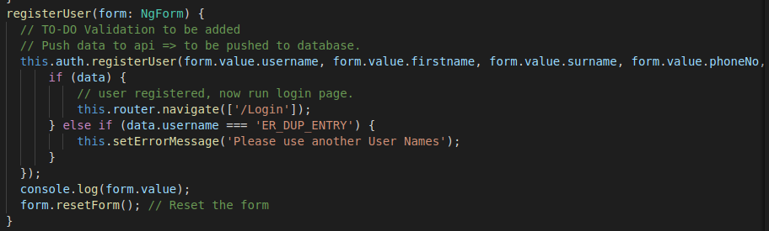

The above image is from the register component typescript where the user is able to register to the database. From the above you can see it's the function that was assigned to the button from the html page where it takes the form values of the username, first name, password etc. If the data is correct then it navigates to the Login page but returns an error message. However the typescript file is not enough for this section of the project to work so that's why the backend is important to the project. In the backend is a javascript file where there is a model for the user where we define the values that the user will enter into and created a function where the user gets created and their data is then inserted into the MySQL database by stating the MySQL query that stores that information. Then in the api javascript file a router.post method is stated where the createUser function is called from the user model to create the user where it checks to see if the information entered has met the right creditainals else not then it returns an error.

**user.js file in the mod folder in the backend**

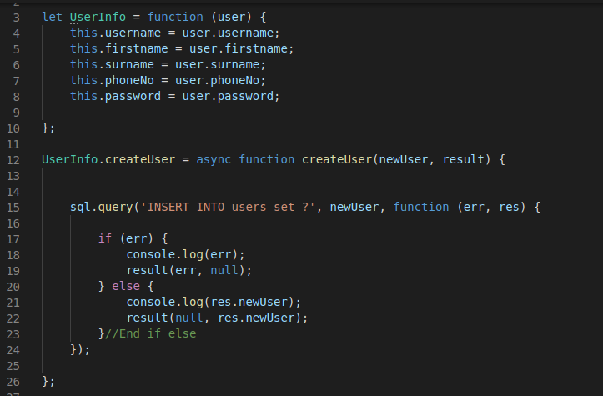

**Post method in the api.js file**

## 

Once the register component met the expectations we had set out and began to insert the data into the MySql database we then set out to work on the Login component of the project now. The development of this began by generating the component in the built-in terminal in Visual Code, then set up the html layout and the css styling for the page. The login proportion was slightly more difficult then creating the register as it would require authentication as it had to make sure that the password entered matches to what the username registered with when creating their account. **[6]**

**Login.component.ts file**

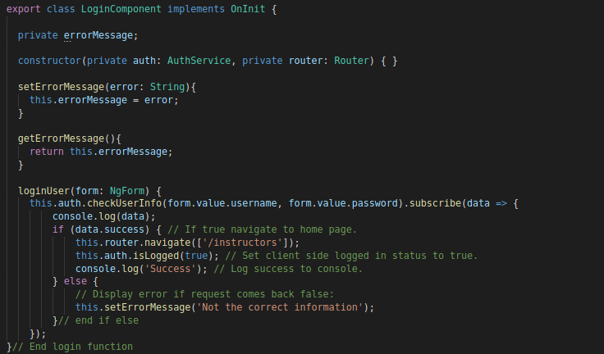

The typescript file is used to check to see if the username and password form values match, if the data entered do indeed match then it returns true and navigates to the instructors page where the user will be able to pick an instructor to book their driving lessons with but if the two do not match then it returns an error stating that the information that was entered is incorrect. In the backend section in the models folder there is a folder called authenication.js that checks to see if the username matches with the password entered from what is stored into the MySql database through the use of a simple Mysql query statement.

**authenication.js file in the mod folder in the backend**

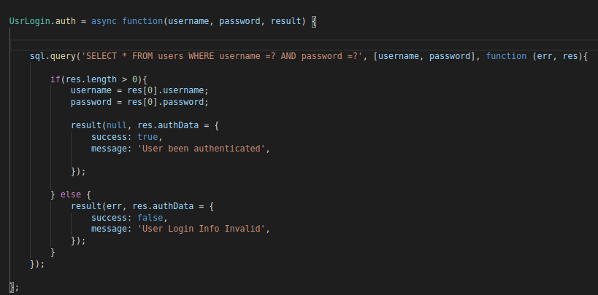

In the Api.js file that is set up in the routes folder we call this function we declared in the authentication model into a post method to make sure that the login will be able to do what we intended it to do. This post method goes to the api that was created for the login section of the project and helps make sure that the usernames(primary key in the users table) match and as well as the passwords matching as well.

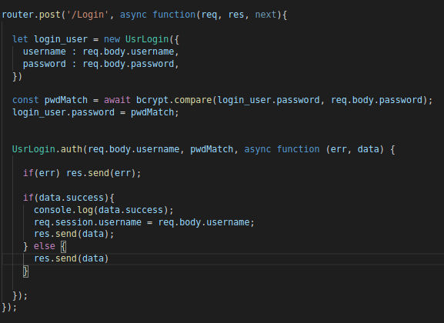

From the above code snippets from the api.js file you can see that bcrypt is mentioned in them. Seeing that the user would have to register with the website to create an account and then login back to that account means that added security measures would need to be met as we both wanted this website to seem more genuine and professional. So we looked into how this could be done. From research I saw that the most known way to do so would be by hashing the password that the user registered with into the database. Bcrypt is a function that's used to hash a password and is used in many other programming languages such C, C++ and of course Javascript. **[13]** Functions for the hashing of the password are used mainly in the backend of the project. First thing that had to be done was to make sure that where the user registered is that his/her/they password is hashed and then stored into the database like so. **[11]**

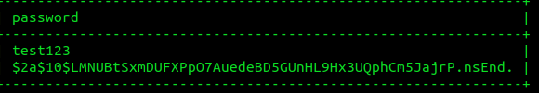

In the api javascript file before we get to the createUser function a constant variable called salt that then calls on the genSalt bcrypt method which asynchronously generates a salt for the password with 10 rounds defined. Then we state a constant variable call hash which calls on the hash bcrypt function which takes the password string that we want to hash and the salt length to generate it. We then state the password string variable is then equal to the hash variable and then state that password equal to the hash in the user object that is declared in the register function afterwards. **[14]**

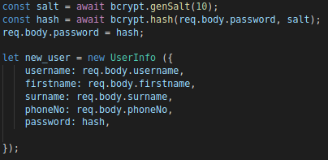

Once this got established it was now time to work on the login side of this. Seeing that the password got hashed, that hashed password is then stored to the database like so from the above screenshot of the password column in the users table from the MySQL databases. This meant that if the users were to enter the password they registered it then it would return “Invalid User Info” in the console but would return successful if the user would actually enter in the hashed password. Seeing that this was a flaw in the project considering that the user would not be entered to know what their hashed password was and therefore would not be able to actually login. However bcrypt has a method that would help us fix this issue. This is implemented in the router post method for the Login api. Here another constant variable is declared this time used to help compare the user password and the hash by using the bcrypt method compare()****[**15]** where it takes the password the user will login it which then compares it with the hash that is stored in the MySQL database. Once this was coded into the project we were able to login to the website with the password that was entered originally when we tested the register component section of the application.

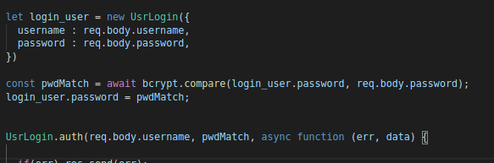

## **4.2.2 Location Component**

When I was developing the location component the idea behind it was that it would display the different locations that I have created in the database. Then in turn it would be styled through HTML and CSS. To achieve this there were a couple of elements that had to be created in order to complete this part of the development. The first element that had to be created was the component for the location. At first I had to work the location.ts page, there were two pieces of functionality I wanted to develop for this component. The first of the functionality is a method that I need to display the data from the database, the data that I need is the information that is in the location table. To set up the functionality that is needed I first needed to make a get request method inside the backend, where our server logic is created. The file that will be carrying out all the requests that is needed will be called api.js and is located in the backend in the routes folder. The element that is going to be interacting with this is our Api. The Api function I have created will make an Api request and then return it. The location component can access the Api service once it's been imported and injected in the construtor. I have defined a property LocationData, I then assign the response from the Api to the property of LocationData. The GetLocation function is being called in the ngOnInit(). The Location component.html displays this data for the web page i have created for it. The last functionality I added to the location page was a search bar for the user so they could search for the location that they are living in. The function is simple, it checks for the letter or letters you have entered in the search bar and filters the letters to name that match them. Once the search bar is empty its calls on the ngOnInit function to repopulate the page with the instructor list. To conclude the location component is tightly coupled as it depends on the api service for the requests of the data that are being executed in the server class.

**GET Request in (api.js) Location data**

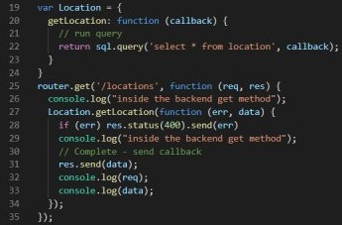

**Api request on getLocation data in (Api-service)**

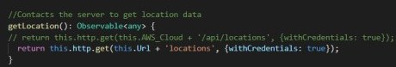

**Location component is then receiving the data.**

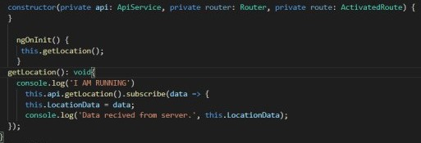

**Location HTML page**

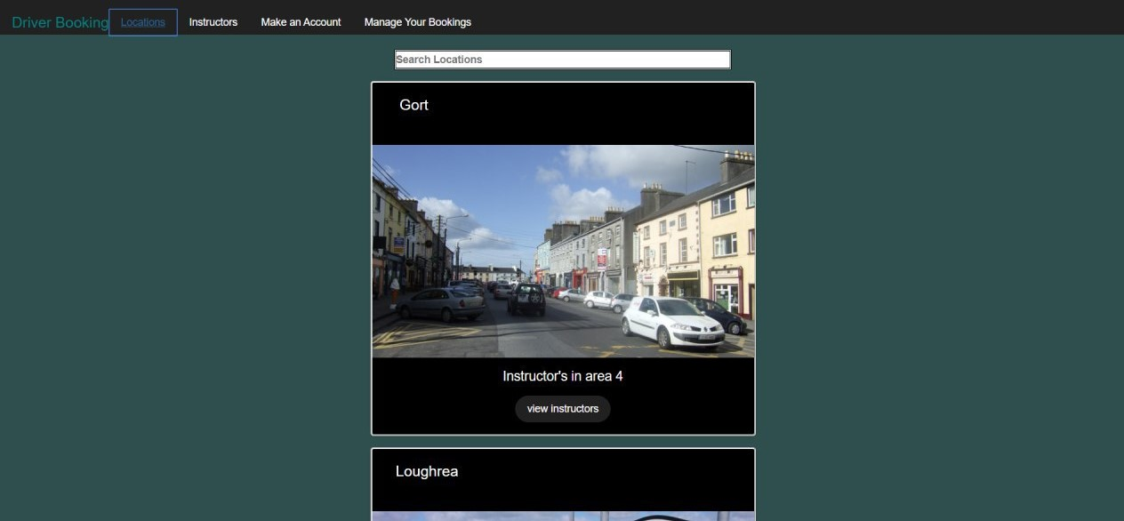

## **4.2.3 Instructor Component**

This component and the location component are very similar in some ways. As they are performing the same action on the Api service it will make a request and return the data. In this component the data is different as it will be returning instructor data to this component to be displayed in the HTML page. In the api.js file there is a similar Get method that will allow us to retrieve the information from the database about the instructors, the next piece of functionality that I added was a button to cancel your bookings, this button will bring you directly to the booking-details page. On this page you can manage yours bookings I will talk more about this section in its system design. Also there is another button next to the last one just mentioned. I designed this button so that when it's clicked you will be brought directly to the make a booking page. As the button is placed on the card in the html page on this card displays an instructor with their name displayed on top a picture of them, in the middle of the card and also there email, on the bottom of the card is the two buttons.

**HTML Instructor page**

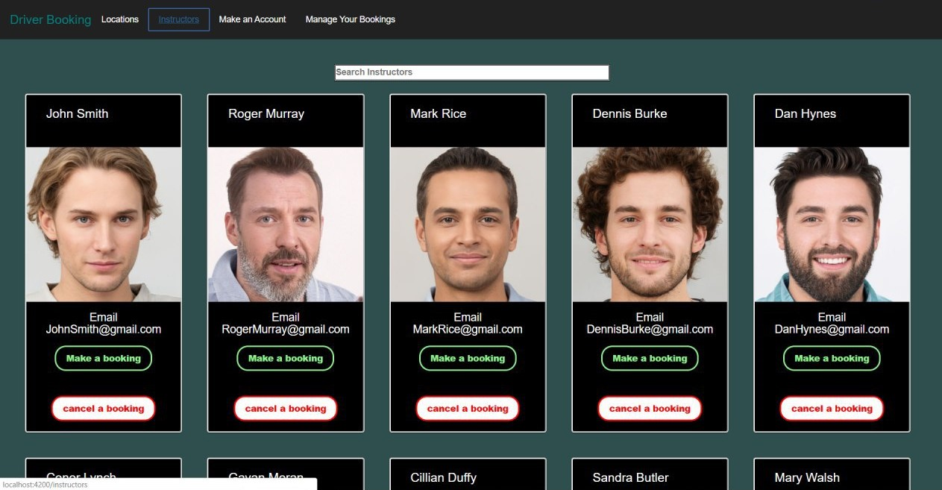

## **4.2.4 Instructor-Details Component**

The Instructor-Details component can only be accessed through the Location Component, as there is a button on the location page on its display card. The button will bring you to a page similar to the instructor page, but these images you see will only display the instructors in their locations. To achieve this the first step began in the api.js file where a Get request method is set up to acquire the data from the database. The way I set up this Get method is that it's getting information from the database by an id in the instructor table. To implement this into there were a couple of things that needed to be added to the imports. The first was the instructor model. This class will be used to hold the data coming from the Api service, we extend the instructor to Instructor-details component so that it can be displayed in the HTML. Another import we had to add to the component was the Activated Route module, this had to be injected into the constructor. It then exposes an observable through its params property which we subscribe to. The information that has been requested is then stored in the instructor model. After all that then it is able to be displayed in the HTML similar to the instructor page but now showing the locations the instructors are in. This component is tightly coupled to other components like the location component and the Api service.

**Get request method by id**

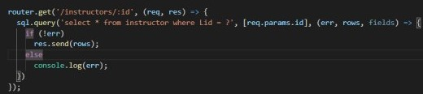

**Api request method get**

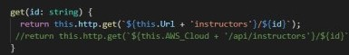

**Instructor component class**

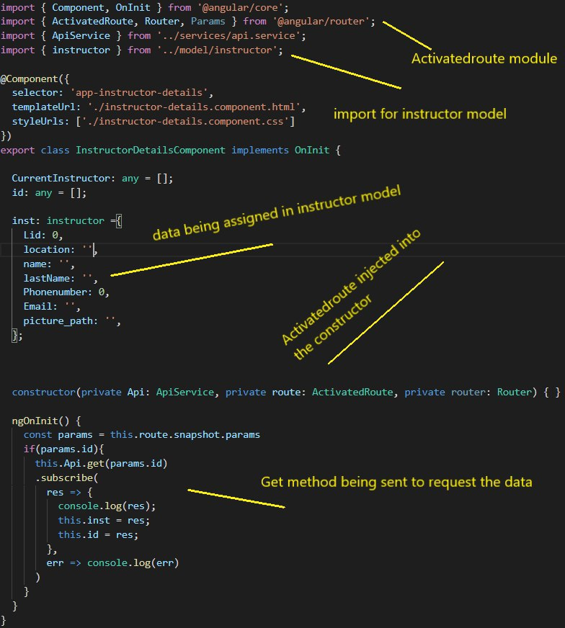

## **4.2.5 Booking Component**

This component is very important in the project as the rest of the components left rely on this component to provide the data and information that's needed for them to carry out their functions. The first step I did to start the booking logic for the project was in api.js file. In this file began implementing a post method in order for the user to send the values they need to pass to make a booking. Also when the values are being passed on to the model in the server I have made a check to make sure that the table in the database is not being sent empty parameters. Once the data has been sent to the model without any problems we will receive a message in the console that the request was ok. In the backend where the server is located there is a model class called bookings.js. In this class I have a function called BookingInfo which has been assigned the values for which will be needed for the database. The values that are assigned will have data sent to them and will add them to the database. To add them to the database a simple insert statement in sql will add them to the booking table. The next step is to do with the Api service in tandem with this is the bookings model, this was set up to pass the values to server logic. The next step I did was in the booking component here I had to implement the form logic. Essentially what is being done is that I am inputting the data on my HTML form that data and once I click to add a booking, the logic in the component will send the data to the Api and then to the server logic where then it will be inserted into the database table for bookings. There is another element of functionality that I added to the booking component that I have briefly mentioned in the instructor-details component. The essence of this functionality is that once you pick an instructor on either the instructor page or instructor-details page and one you click make a booking with that instructor, his name will be populated in the booking page once the page has loaded. The way I implemented this logic was similar to the way I got the Lid (Location id) of the instructors in the Location component. In the booking component in the ngOnit method I am requesting the api to to send on the id of the instructor that I have chosen from the instructor page. The Api sends the get request to the server where the get method is getting the id of instructor from the database. The booking component is very tightly coupled to the instructor components and also the Api service class, as it depends on the user making a booking, the only way to make a booking is to actually pick an instructor to book with.

**Api.js in server post request**

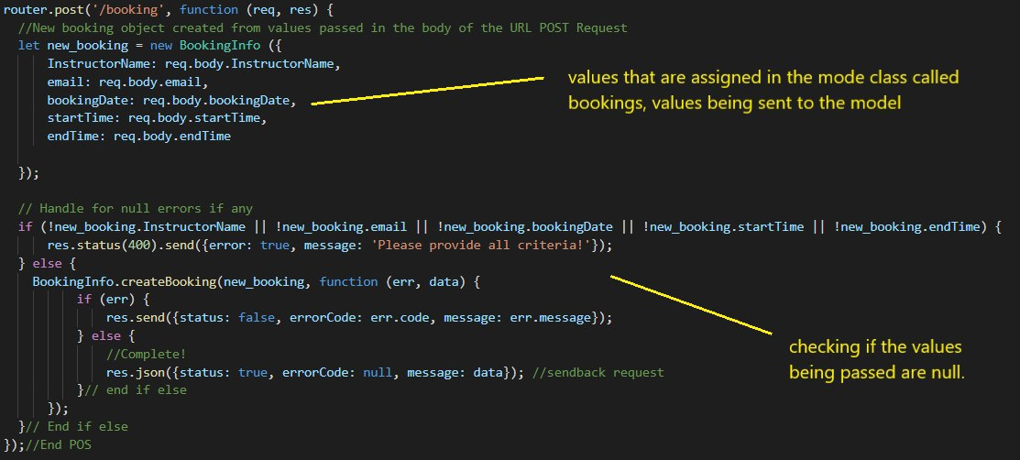

**Api.service class request to make a booking**

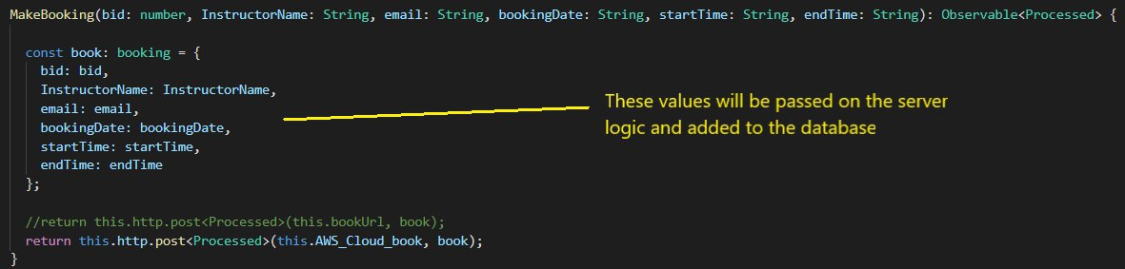

**Request to api to get Instructor id**

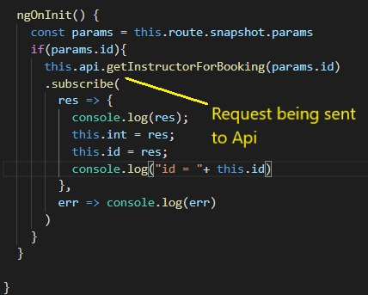

**Booking Html page**

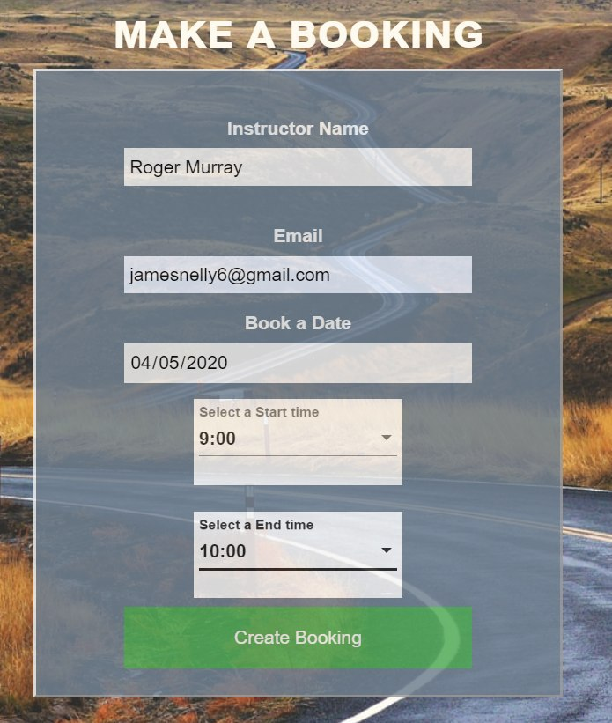

## **4.2.6 Booking-details Component**

This component allows you to view the bookings that you have made and can manage them. The way I have implemented how to manage the bookings is very simple. At first the page will display all the bookings and you then have the option to delete or cancel the bookings, also you have been given the option to update the booking of your choice and they are displayed on the web page as buttons. These options that follow the update are the bookingDate the startTime and the endTime. I will talk about the update component in its section. When implementing the logic on this component I begin once again in the server. The first element I added to the Api.js was the get request to acquire all the bookings in the database, also there is a bookings model file where the sql statement is being carried out in the database. The next method that was carried out in the api.js file was the delete method. This delete method is deleting the bookings by their id that I have assigned to the booking in the database. In the api.service class the requests are being made to the server and they return with the data and with the delete method the booking that has been deleted has its id attached to the request in the api. Lastly in the booking-details component the method that requests the booking info for all the bookings is sending its request to api once the request is ok the data will return. In turn the bookings will be displayed in a column format on the HTML page. The delete method requests to delete the acquired id it has got from the bookings that have been displayed on the page. When you click on the delete button the booking will be deleted and the page will refresh immediately showing the bookings you have made. Also a message will appear stating that your booking was cancelled successfully. The update booking button will navigate you to the booking-update component.

**Api server logic on get request on bookings & delete**

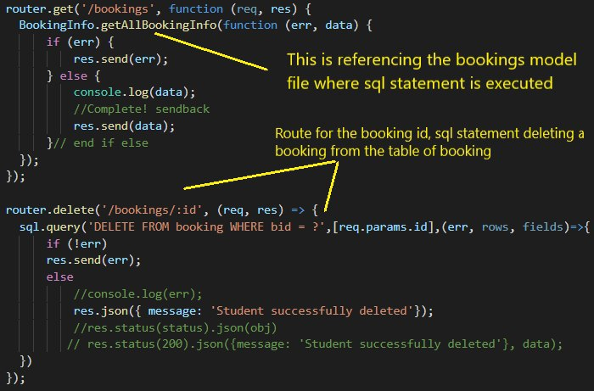

**Api.service making requests on these methods**

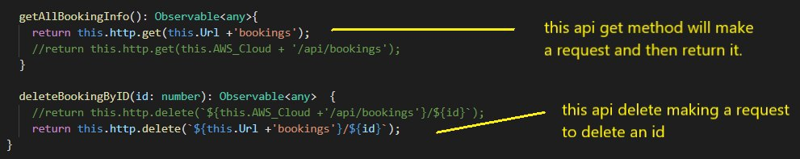

**Booking-details Html page**

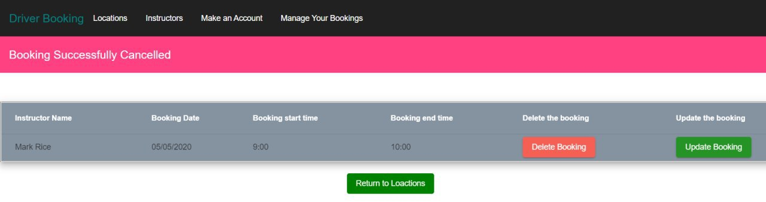

## **4.2.7 Booking-update Component**

When starting to develop the booking-update component, there were different elements of functionality that I wanted added to this component. The first element was that once you clicked on the update button in the booking-details component it would navigate you to the update component where the booking you clicked to update, the values of that booking's date and times would be already populated in the input boxes in the update component. This would show the user the previous dates and times that they had chosen for that previous booking. The element of functionally that is the main part of this component is actually being to update the booking successfully. To begin I started in the backend of the routes folder in the file name api.js. In this file I am creating a post method to update the values of the booking set, the values being updated are the date of the booking and the time the booking starts and the time the booking ends. A simple sql statement has the values passed from the api.service file it then uses the booking id (bid) to locate the correct booking to update in the booking table. To get the values passed into the input boxes a get request on the booking id is also made in api.js file. The routes used in both these requests are on the same route, they do not conflict one another. The next step that had to be was in the api.service file so that requests in the server were useful. The api methods created the first were a get request method on the booking id. The next request was the update booking method where the data from the component would be sent to the api and then to the server to carry out the update. The next step was to implement the methods to make these requests in the component to the api. The model had to be set up to pass the info from the component to the api. The updateBooking method is set up to take in the new booking date and times from the form in the HTML page. Once the update has been carried out the page will navigate you to the managed bookings where you will see the updated booking. There is also the method that is requesting the id of the booking details to be displayed on the page where you are updating.

**Api.js performing the requests for the update component**

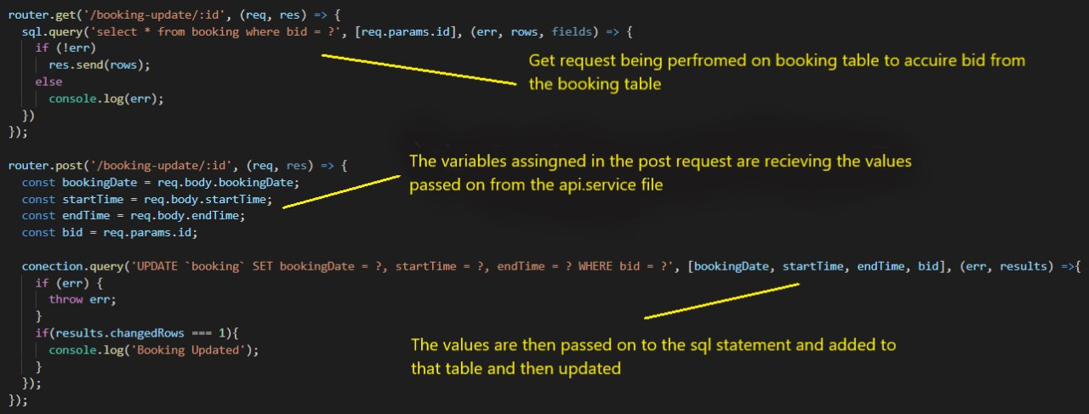

**Api performing request on update method and getBookingId method**

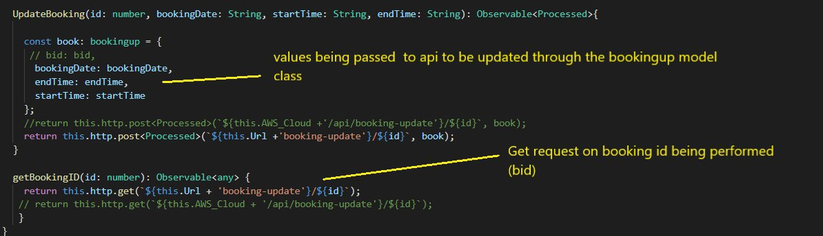

**Booking-update component HTML page**

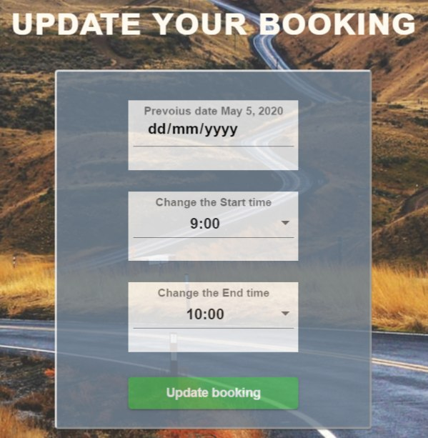

## 

## **4.2.8 Api.service**

The api service will communicate with our backend server to do this using HTTP protocol. Angular provides us with a simplified client HTTP API for angular applications. The module we imported to allow this development is the HTTPClientModule. It's written in typescript language and it uses observable techniques to pass messages to parts of the application. When the api is requesting data from the server it sends a HTTP request and then returns an observable that emits the data that was requested when the response is received.

**Why we used the HttpClient**

We used the HttpClient as its come already built in with angular and a simple import will add to the service, it also makes it a lot easier to process HTTP requests and their responses

**Post Request**

In our application we send two post requests when making a booking and updating one. In this application we are sending these 2 post requests to the server when we are submitting a form in the web page.

**Delete Request**

When performing the delete request, the application deletes the booking with the HttpClient.delete method by passing the bookings id in the request URL.

**Get Request**

I have many requests happening in this application. They work like this, the client will sends A HTTP Get request to the server to retrieve the data it needs to display on the web page. Once the server has sent its response the TCP connection is closed.

## **4.2.9 Api.js file**

This file is located in the backend of our application. This file carries out all the requests that are needed in order for the application to be functional. Also most of the routing takes place in this file. Routing refers to how the applications endpoints (URLs) respond to client requests. The routing methods specify the callback function when called the application will then receive a request to the specified endpoint and HTTP method. The application is always listening for the requests that match the route that it is intended for. When it finds the route it has been listening for it calls the specified callback function.

**Server (Backend)**



**Api Service (Middleware)**



**FrontEnd (app-routing.module.ts)**



## **4.2.10 Server.js file**

This server file is located in the backend, this file provides the middleware needed in express for the use of the application. Most of the packages installed for the application are assigned in the server file. The middleware functions are functions that have access to request object, response object and also the next function in the applications request-response cycle. The middleware functions perform tasks like executing the code, end the request response cycle and it will call the next middleware in the stack.

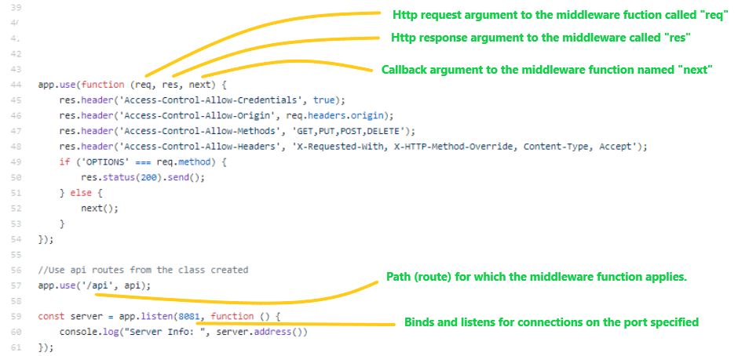

## 

## 

## **4.2.11 Header and Footer components**

## 



When beginning developmenting any website or application it is normally common to start off with creating the header at the top of the website and the footer at the bottom. The development of these components may have been the easiest to create during as because we had experience in using Angular and headers and footers are very basic. The header component was used to display the name of our project and to present the links to the main pages such as the locations page, instructors page, etc. Once the user clicks on these links they are then moved to the page they clicked on and all the while the header will still remain. In order to do so we created the links as router links. Router links are used for enabling the user to go through each of the components on the application. However to get the router links to work, first we had to assign a path to each of the components. The paths were established in the app-routing.ts file that is in the ‘src’ folder.

App.routing.ts where the paths are assigned to their respective components

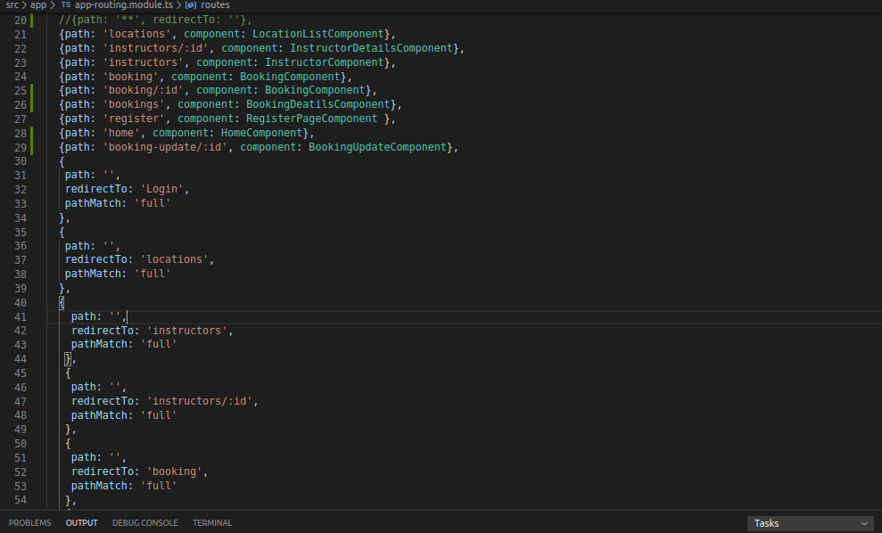

Header component html code where the router links are stated

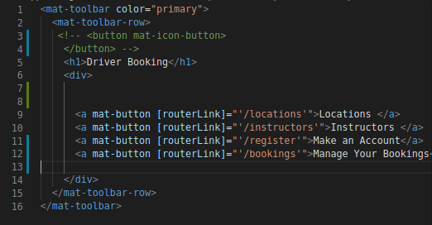

The next step was to build the footer aspect of the website which again was simple to do like the header. In the footer there are links to the other components of the website that were stated in the header including the login component and some of the links there that were stated in the header. In addition to this we also had links to social media sites to the Road Safety Authority (or RSA) of Ireland accounts on Facebook, Twitter etc.



## **4.2.13 Config.js**

The config javascript file in the backend is used to set up the connection to the MySQL database and the AWS cloud service to the Angular application we are creating. In the file we declared what would be needed to be stated for the project such as MySQL, Express, Body-Parser etc.

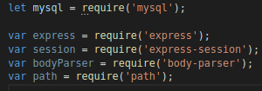

In the beginning stages of the development of the project we had set up the MySQL database locally which resulted in creating the database on each of our laptops/computers separately. We create the function in the file where the host, user, password and the database are stated. As a result of us having separate machines we both had to specify each of our passwords that we used to get a connection to the local database.

Connection to MySQL initiated

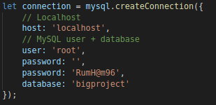

We also create the connection to the AWS cloud service where like above we state the port number we would use for the project, the username and password that would be used. Once the AWS cloud gets connected to the project this means that we would be able to run the project globally and also be able to send data and read the data to/from the same database from anywhere so James would be able to do so from Galway and Brendan from Roscommon.

Connection to the AWS cloud port number

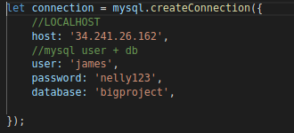

## 

## 

## 

## 

## 

## 

## **4.3 Flowchart Diagram of the booking workflow**

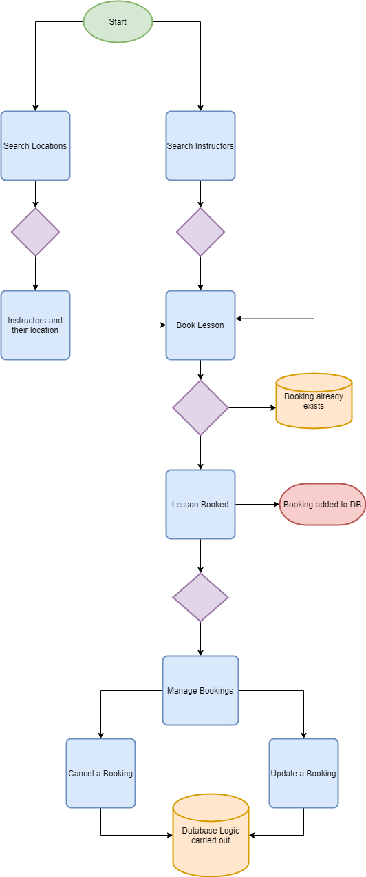

The diagram above describes the workflow that takes you step by step through the various processes that take place in the application, For instance finding the location you want with the instructor in that area and also making that booking and adding it to the database,and taking into consideration the chance of duplicate booking is being taken care of. Also the workflow of managing your bookings.[25]

## **4.4 Flowchart Diagram of the Register/Login workflow**

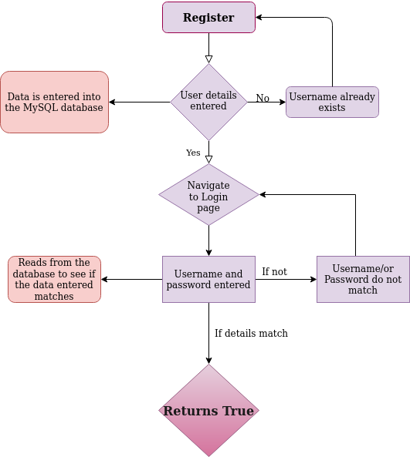

This diagram describes the workflow when wanting to make a new account within the application and also having the ability to login to your account.

# 

# 

# 5.0 System Evaluation

## **5.1 Testing methods in server**

Our first wave of testing was based around the Get Post and Delete methods in our server. These tests were most important to us as the application depended on good and accurate requests that had to pass correctly. When testing for these requests on the server the application that I used was postman which is mentioned in the technology review. To carry out these test in postman, there were a couple of steps that had to be carry out to make sure i was testing the correct route and also the correct type of request method

**5.1.1 Get Request testing using Postman**

* The first step when testing a Get request with a postman set the type of request you want.
* The second step is the enter the correct request url this is so that you are testing the correct route in the server
* The last step is easy just send the request and wait a moment or two for the results
* Once the status you get is 200 and the data you expect is outputted then the test is a pass

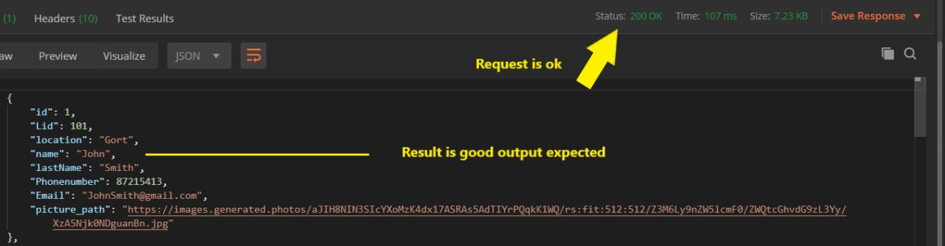

## **5.1.2 Post Request testing using Postman**

* The first step when testing a Post request with a postman set the type of request you want.
* The second step is the enter the correct request url this is so that you are testing the correct route in the server
* There is an extra step when testing a post request as there has to be json data to post to the server then we send it and wait for the response.



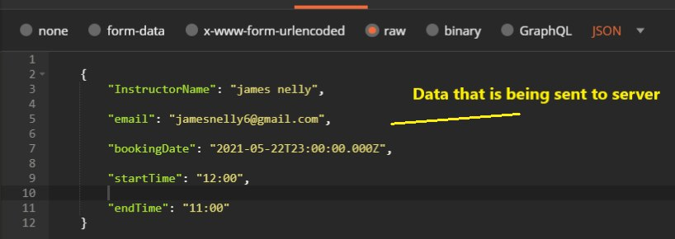

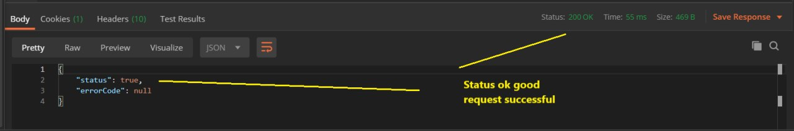

## **5.1.3 Delete Request testing using Postman**

* The first step when testing a Delete request with a postman set the type of request you want.
* The second step is the enter the correct request url this is so that you are testing the correct route in the server
* The delete request is a bit different as the delete request deletes by the id of the booking so we pass the id of the booking in the request URL and then we press send and await for the status code.



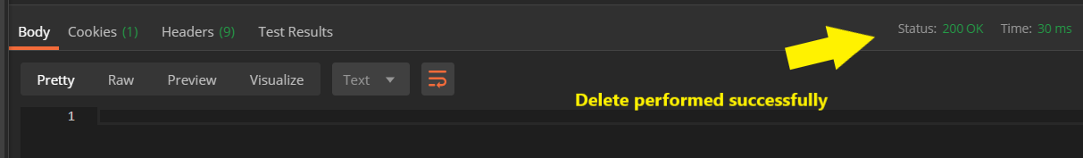

We found the postman application to be very helpful when testing the different routes and requests as it was a quick and efficient way of carrying out these tests as you get the result in no time.

## **5.2 Users testing the Application**

As I had mentioned before in the introduction we were in contact with 2 separate driving instructors and I had chat with them about the solution we had come to devise for the application. They were intrigued so I decided that I would let them test a beta version of the application when I knew that it was at a stage for us that most of the functionality was working to what we expected. To allow the instructors use the application was a bit of a challenge due to the coronavirus pandemic and travel restrictions. I came with the idea that

they could get set up on microsoft teams and that they could then interact with the application. It was a bit of a challenge getting them setup on teams, as they had never used technology like this before, so I had to run them through how to set it up and how to take advantage of the option where you could allow the user to take control of my screen. Once we got past that it was quite simple for them to use it. When I allowed the instructors to use the application they were impressed at how far we had got since we had last met as we had just talked about how we were going to start to build and what we were going to implement to develop the application. They first made an account on the register page and after they logged in with the details they provided. They next noth made their way through the locations page and both of them searched to see if their location of work was in the location list. Once they both found their respective locations they went to view the instructors in that location a list of instructors appeared on screen for them. Next they picked an instructor to book a lesson with. They both added different dates and times for their bookings. They were quite impressed with the layout of the booking details page as they said it was clear to them about the bookings they had made and the details that followed those bookings. They liked the idea that it was so simple to delete a booking. They thought the update booking page was good as it displayed the dates and times of the previous booking they had made. All in all they quite liked the website and thought it quick to load the different pages up. They also thought the layout was simple but elegant.

## **5.2.1 Data taken from testing**

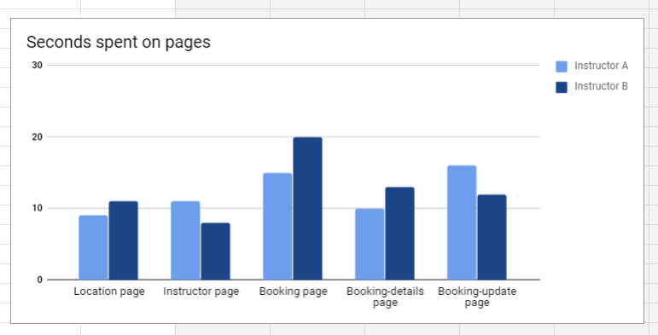

While the instructors were using the application I was writing down some that later that I thought would be useful in the evaluation and I did a questionnaire with the instructors just to gauge their experience of the website. The results are below.

## **5.2.2 Instructor A Feedback**

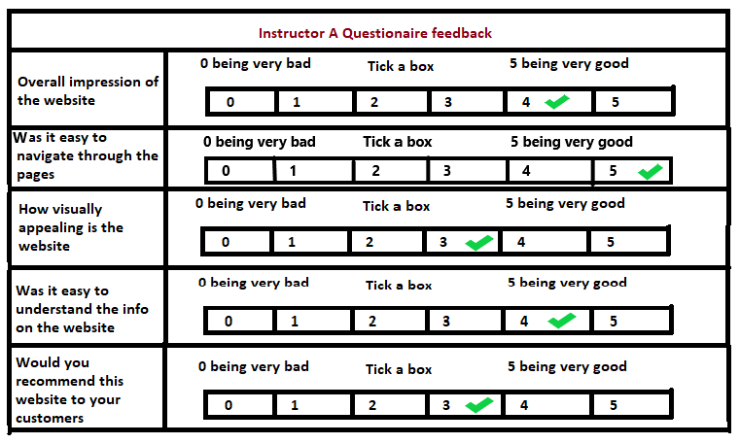

## **5.2.3 Instructor B Feedback**

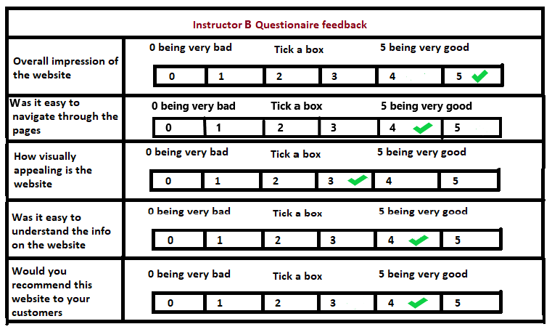

## **5.3 testing the Website on different Browsers**

Since we have developed a website I decided to test the website on different browsers and if there is any difference between them. The browser I mostly used to test and develop the website was Google chrome. The different browsers I decide to test the website on are Mozilla firefox, Microsoft Edge and Opera. As these browsers are the most widely used ones. I decided to just test the instructor page on the browsers named above. There was some small difference between the instructor page on Opera, there was a wide gap at the end of the instructor listings. The next page I tested was the booking page on the various browsers. I noticed in the microsoft edge browser the booking was not what i expected the input boxes were very wide not the proportion that I had developed in chrome. I know sometimes they come out differently in some browsers. On a good note the rest of the browsers were scaled the way I liked it and I had implemented it.

**Google Chrome Microsoft Edge**

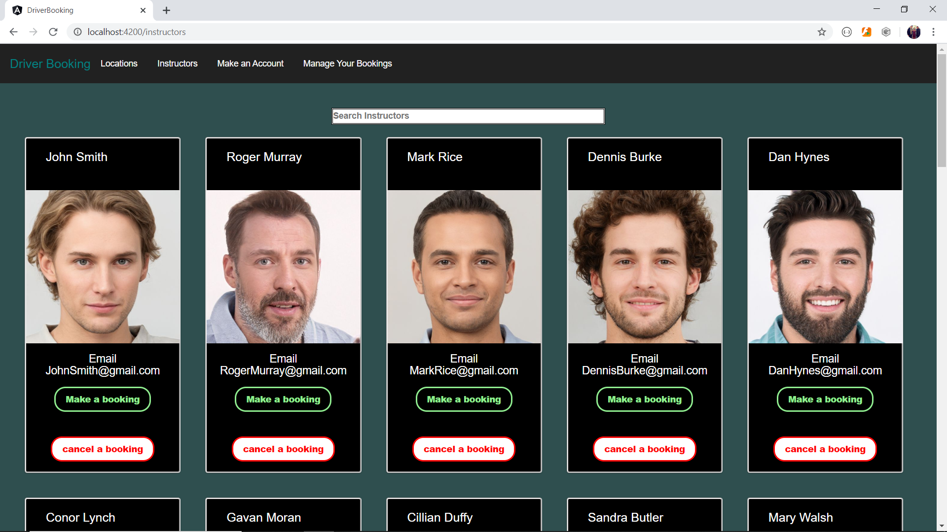 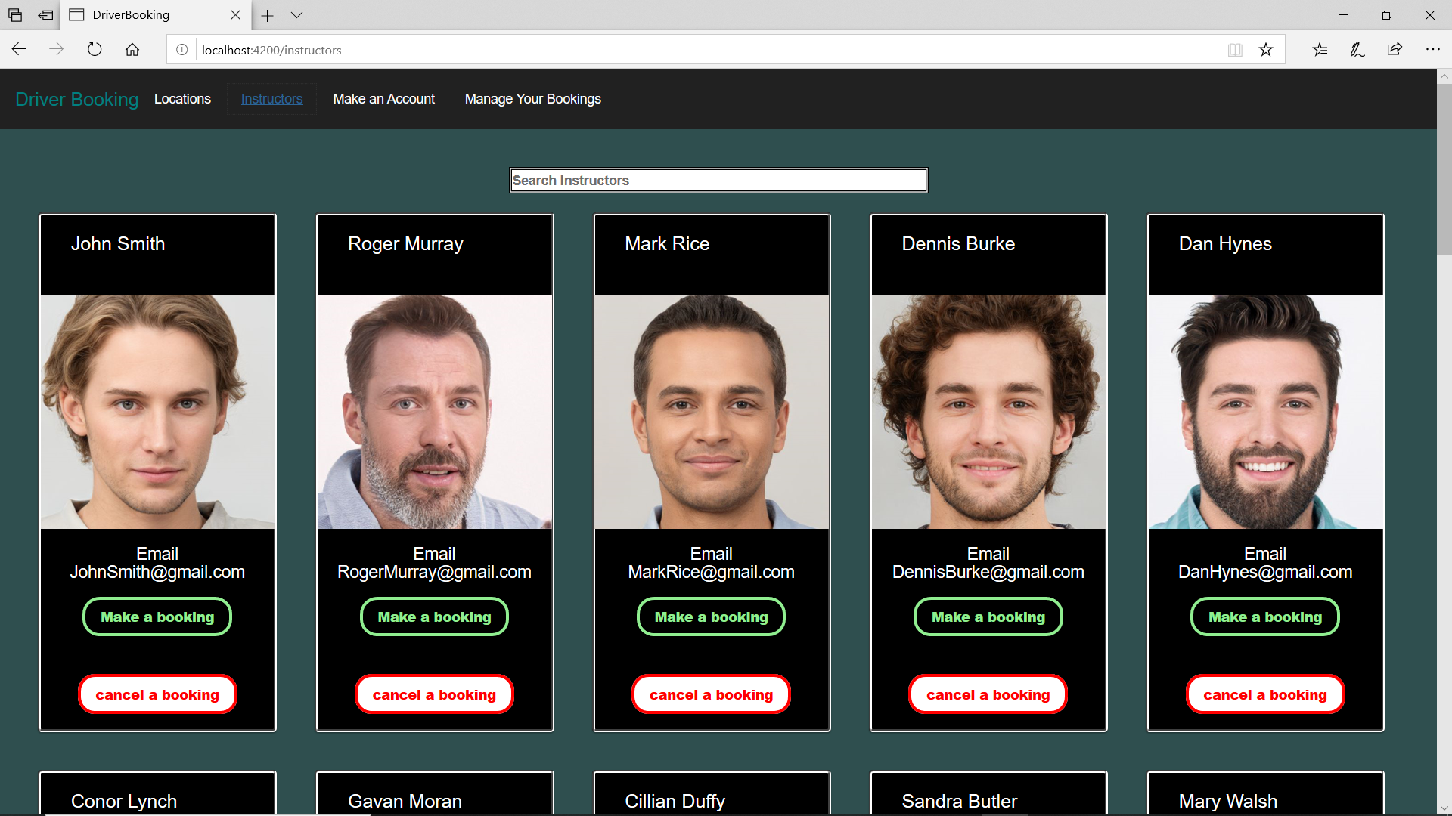

**Mozilla Firefox Opera**

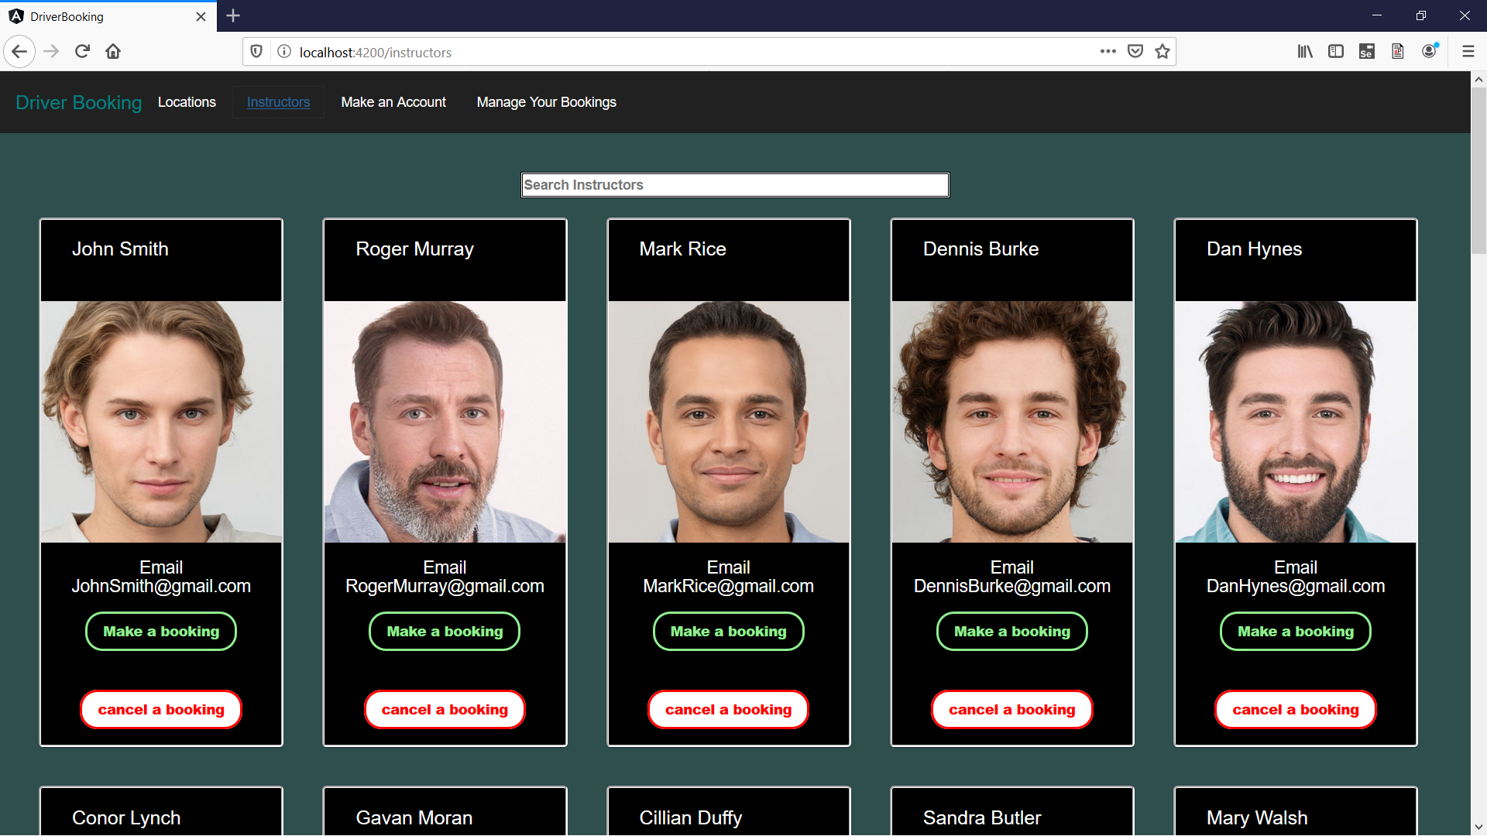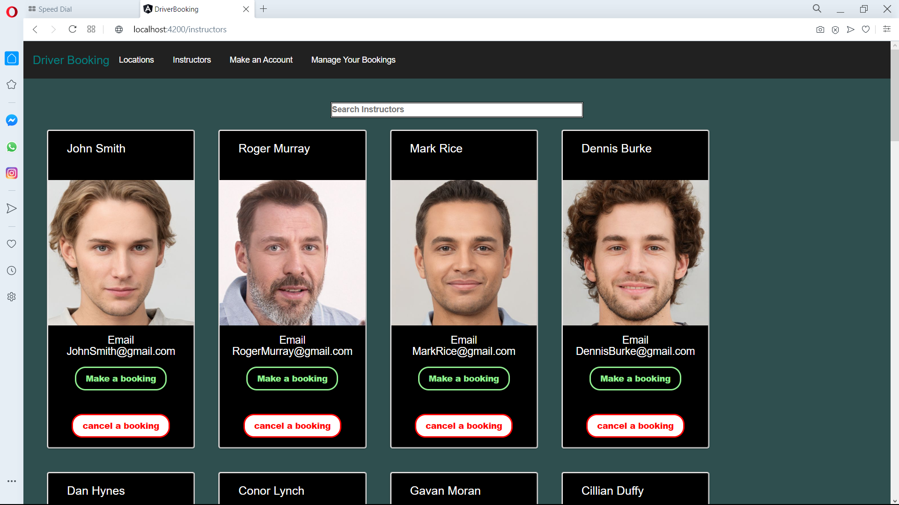

**Google Chrome Microsoft Edge**

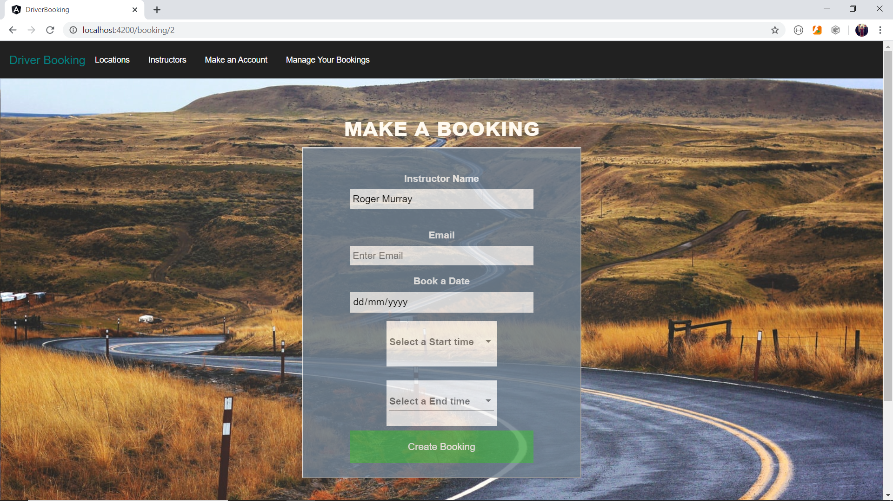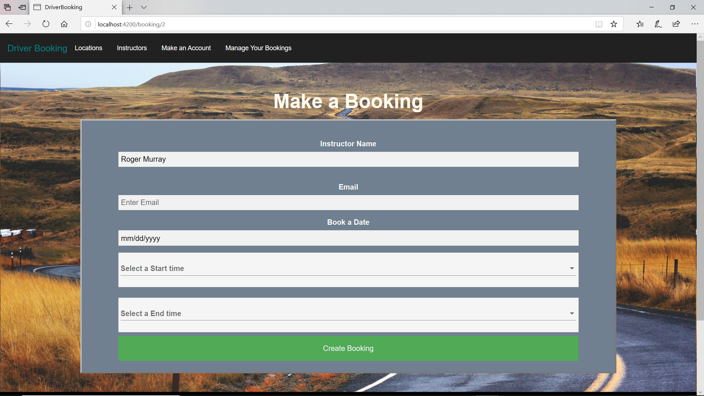

**Mozilla Firefox Opera**

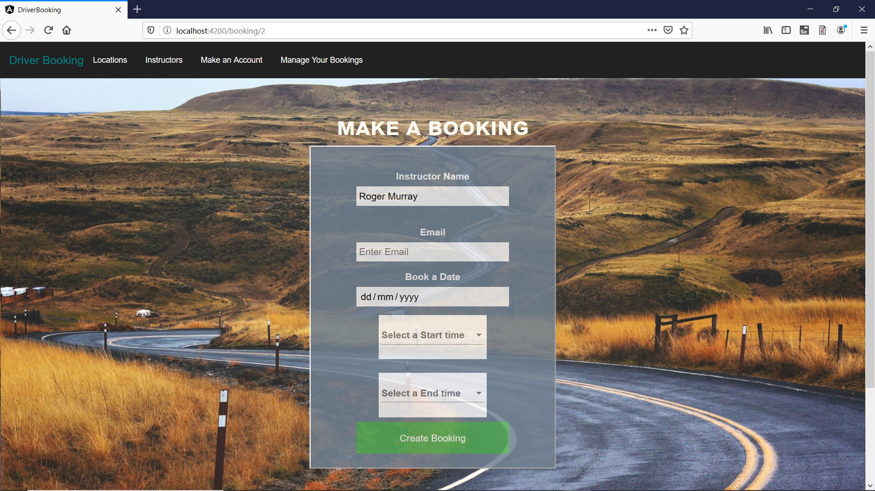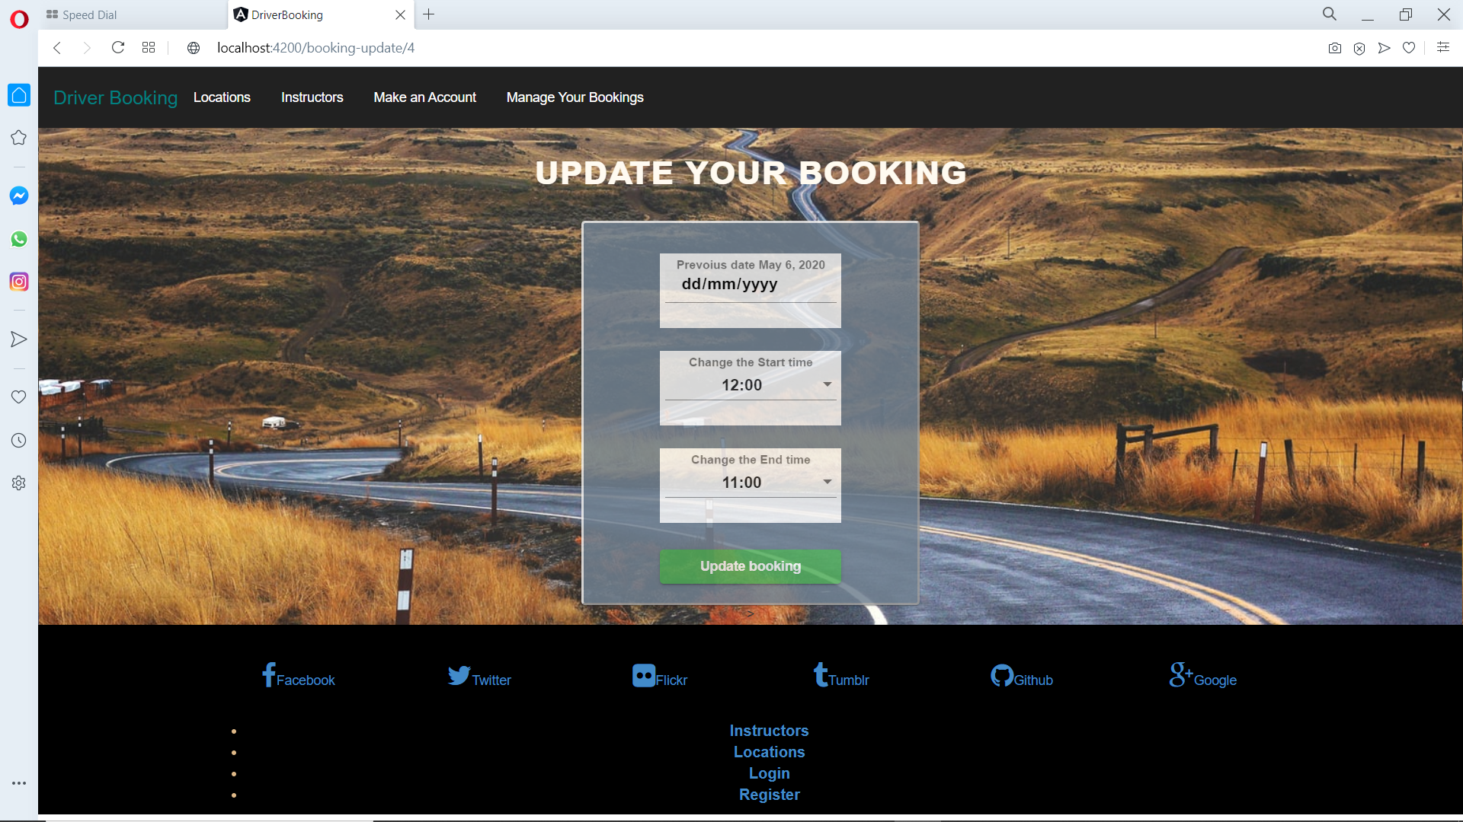

## **5.4 Limitations and Problems we came across**

1. The first problem we had encountered was at the start of the project when we were picking the server. We decided to use Flask as our server as I thought it would be a suitable server to use for the development of the project. Unfortunately Flask is written in python and uses it as its syntax also. Personally I never had much experience with python as a language. I felt it would be a good experience to try a new language and get to know how to use the different libraries that come with it and also try the different components that it has to offer. When I was researching flask and its inner workings I found it difficult to wrap my head around it. I myself always had problems trying to learn a new language as with a new language the syntax always gives me trouble as the syntax changes with the langued very slightly in some cases but more in others. To overcome the problem that we had run into with flask we decided to act quickly as our first major step in the development of the project was connecting our server to our database. So we came to the idea that we would use node.js (express server) as we had used it in a module so we had a small bit of experience using it and plus side to this as well is that when writing code in the server it is all in javascript which we had used in many modules through our years in college. Within a couple of days of changing the server we managed to connect it to our mysql database and got it carrying out some basic Get request methods. We had overcome this problem relatively quickly.
2. The next problem we encountered was the implementation of using google cloud to host our server and mysql database. This problem happened in the last month of development of the project. I had implemented the database and the server on a virtual machine and was getting the ports set up to allow access on them through the different ports. The problem that i ran into was that the google cloud instance did not offer a public DNS (IPv4). This IPv4 address is reachable over the internet. I could use this public address to access the instance over the internet and through the application. I got in touch with google tech support to see if they could offer me some kind of a solution unfortunately that path led nowhere. To resolve this issue I decided that I would use Aws to set up an instance on their cloud platform. Thankfully last year we used aws in our database module so I had a fair idea on how to go about setting up the instance and also the way in which google cloud and aws setup there instances are quite similar to one another which was a help. When I had set up the instance and applied all the changes that I needed to do for it to work. The IPv4 address is located in the window in which you startup the instance. Once you start the instance you are provided with an Ipv4 address and I noticed that every time you start the instance you will be given a new IPv4 address. After this I connected my application to the IPv4 address in my Api.service class and ran my server on the instance I had success as the requests were working and it was indeed connected.
3. A major problem we faced during the development was the fact that we both were using different operating systems on each of our machines. James using Windows 10 and Brendan using Ubuntu Linux. Brendan had recently switched operating systems on his machine which meant that he would have had to install everything he had on his old operating systems again. Seeing that Brendan was still learning the in’s and out’s of Ubuntu and as well the different command lines. First off there was an issue when installing angular as at first Brendan had thought he had after running the command line. However this was not the case as it did not fully install on his machine. Thankfully we had a peer in our course who encountered this problem before and knew how we would be able to solve it. This same person was able to help us set up MySQL on Brendan’s machine as we were facing issues there as both of us had very little to none knowledge of the operating system.
4. Another problem we had to deal with was the logging into the website. During development we used bcrypt functions which would be used to hash the password the user would register with. The problem here that we faced was when afterwards the password gets hashed and then that hashed password gets stored into the MySQL database we were not able to log into the website application as it kept returning ‘invalid user info’. The problem was that the website would actually recognise the hashed password but not the original password. This problem persisted for a week which led to Brendan having not to attend one of weekly meetings with our supervisors so he would have more time to solve this complication. Fortunately this problem was solved and then led us to be able to get back on track with the development of the project. The problem was that in the byrcpt compare function it was calling on the wrong variable that was to be compared with the password that was getting hashed.
5. A minor problem that Brendan faced was his laptop. His laptop was the machine he had been using since first year of college so it wasn’t able to run as fast and perform as it used to. When running angular through the command line it would sometimes result in the laptop sometimes crashing and freezing up if there was an error in the code that was not solved beforehand. It’s response time would be slow. This was the main issue why he had moved to using a different operating system as he was told it would run better and faster. Although this was the case at first the laptop still had these issues over time. These problems proved to be tedious especially during the weekly meetings when Brendan would try to run the project to our supervisors.
6. A limitation in the application is the is to do with the feature with the user logging in and being able to manage their own bookings. Unfortunately i was unable to add the implementation where once you logged in with your username and password the application would not know that this user is logged in. I believe it was to do with an active session of the users not being tracked. This in turn will lead bookings being made in the database without the knowledge of which user had booked them. I had researched on how to solve this solution but unfortunately came to no avail. I made an error in this part of the development and did not allow time for its implementation. Fortunately the main elements of the booking website work and I feel this was one part should not determine the outcome of the project.

# 

# 

# 

# 

# 

# 6.0 Conclusion

## **6.1 Conclusion**

This part of our dissertation will review our project in terms of the purpose of the original intentions and to examine our findings and the result of the project when we had completed it. Hopefully by the end of reading this chapter you will gain an insight to how the both of us feel about the project and what we learned during the development.

Our final year project was the development of an Angular Application built using Visual Code which was a website where a person is able to book driving lessons with a driver instructor in a certain area which they can also choose in the Galway area. This information would then be inserted into a MySQL database which is hosted on an AWS cloud service that we have set up and can both access from anywhere.

## **6.2 Goals and Objectives**

Within this part of the conclusion we will state what our original aspirations that we had set up for our project even if we were to accomplish them or not. We then would add a comment that will state if we were able to do so or not and explain why.

* **Successful** - Develop an Angular application that is connected to a MySQL database and host it on an AWS Cloud service where we can be able to send data to it and read from it.
* **Successful** - User is able create an account by registering with the website with there username, first name, surname, phone number and password. This data is then inserted into the database.
* **Successful** - User is able to log back into their account by entering their username and password which is read from the database.
* **Successful** - When the user creates the password that password is then hashed and the hashed password is then stored in the database. We did this by using bcrypt in our application.
* **Unsuccessful** - An user account page created. We were unable to develop a page where the users info is displayed and as well as any bookings they might have made as we were cut from time due to persisting issues at the time and as well as the nature of Covid-19.
* **Unsuccessful** - Timetable displayed that shows the available dates and time to book a driving lesson with an instructor. This was not attainable as it was James realised that it would cost us money on a monthly basis and it was not viable.
* **Unsuccessful** - Logout button did not get created as we did not have time in the end of the development to create it due to the quarantine lockdown.

## **6.3 Final reflections of the Project**

This section of the conclusion chapter is where we will talk about the outcomes of the project, our experience gained and the knowledge we acquired during the development of the project and discussed how we feel now as software developers from doing this year long project.

* When we began doing this project we both were reluctant to use Angular for the framework of our project as we both had problems using it in the past and thus wanted to avoid going through those issues again. We also wanted to use a programming language we had no knowledge or experience in using so we could be able to learn it along the way and we both thought it would have looked good when submitting the project. However when we had to change the framework we decided on using Angular because despite having issues with it in the past, at least we still had knowledge and experience using it. Overall in the end during the development our initial outlook on Angular has changed greatly. Seeing that this was our final year project we had to take the time to research what we would be able to do with Angular. We both went over what we had already known about Angular and also learned some new features of the framework that we could incorporate into the project. The two of us now have a better sense of Angular and feel more self-assured if we had to use it again for any projects like so in the future we would not be so reluctant as before doing an application based on Angular.
* Using Scrum Agile Methodology helped maintain a good architecture to our development progress. We found that having a weekly meeting with our super advisors assigned to us Brian and Mark helped us keep on track on the development of the project and was time to get feedback from them. We also then had our one - om -one meetings with each other on every thursday to see how we're getting on and to see if we can fix any errors we had before our meeting with our two super advisors the following Monday. However sometimes we would be able to meet up as a result of working on other projects that were assigned to us. Also these one-on-one meetings had to stop from March onwards due to GMIT closing all its campuses due the ongoing Covid-19 pandemic which results in a lockdown around the country. Although we still were able to keep in contact with each other through the uses of Microsoft Teams , Snapchat and Telegram. We still were able to attend our Monday meetings with teams. However there were still a few setbacks in these meetings as internet connection varied for some and technical issues happened at times. None the less we still were able to talk to one another at times. The Scrum Agile Methodology had been hugely helpful for us and was easy to follow. As a result we both will continue to use this methodology when we find employment in the near future.
* Being aware that this was our final year project we knew that it would require a lot of work. Seeing that this would be the case we both decided that we could lighten the workload on the two of us if we did a joint final year project. We found that working as a team was very efficient as it allowed us to split the work between us so it gave us time to work on other assignments from other modules in the course. Even though we had to continue the development from our homes due the lockdown placed in Ireland due to Covid-19 we still were able to work as team as we kept in contact with each other through Snapchat, Messenger and Telegraph where we discussed the progress we are making with each of our workload and to see if we could be able to solve any of problems we might had. From working as a team we got a better understanding of what is like to work as a team when developing a big project such as this. We also gained additional teamwork skills along the way too which will prove useful for us when we go looking out for future employment in the field of software development.

Overall the whole development of our final year project was indeed at times challenging but at the same time a worthwhile experience. Even though we both did not achieve everything we had set out in the beginning of the development as there were many aspects were challenging as sometimes we sometimes were unable to find certain resources at time and as well as changing the framework of the project three months into the development and also with the GMIT closing its campuses being concerned for the health and wellbeing of all their students due to ongoing Covid-19 pandemic and then the lockdown being in place which limited us working together on the project.However still we both attain a better insight in using Angular while coding and an insight to various technologies we used in the project. We also obtained a better bond giving each other support through the various endeavors and issues, while at the same time maintaining a positive attitude throughout the project's development even with a worldwide pandemic happening at the same time. In the end of all this with all the research, effort and development that was put into our joint final year project, we were both happy with the end product of the project and we both were proud of ourselves as we now know it feels to work on large scale project now and will be able to work on any other future large scale projects we may have to develop in the future and we now both feel more confident as software developers now.

# 7.0 Appendices

Github Repository Link Below is a link for our github repository where the project is stored

<https://github.com/BrendanToolan/APPLIED-PROJECT-AND-MINOR-DISSERTATION>

## **7.1 Installation Guide**

1. The first thing you need do is install Node.js

[**https://nodejs.org/en/download/**](https://nodejs.org/en/download/)

1. Follow all the instructions given by developers to run it on your machine.
2. Once it has been installed, open your command prompt and run this command **“npm --version**”. This command will check the version of node.js you have downloaded
3. The thing you need to download is the angular CLI
4. To install the angular cli you must follow you must open your command prompt and enter this command “**npm install -g @angular/cli**”
5. To check if it installed correctly run this in your command prompt “**ng --version**”
6. You will next have to clone the repository from github but first you must get git bash and download it on your machine this is the link to it

[**https://gitforwindows.org/**](https://gitforwindows.org/)

1. Once that is downloaded is complete you will use git bash to clone the repository into a new folder this command will clone it for you in git bash “**git clone https://github.com/BrendanToolan/APPLIED-PROJECT-AND-MINOR-DISSERTATION.git**”
2. Next you will need to cd into the “**DriverBooking**” where you placed the cloned repository. You will need to enter this command to install some dependencies “**npm install --save-dev @angular-devkit/build-angular**”
3. Once that is done you will then be able to compile the angular project and enter this command to compile it “**ng serve --open**”.

# 

# 

# 8.0 References

#### **[1]** [**Garfinkel, Simson, and Heather Richter Lipford. "Usable security: History, themes, and challenges." Synthesis Lectures on Information Security, Privacy, and Trust 5.2 (2014): 1-124.**](https://www.morganclaypool.com/doi/abs/10.2200/S00594ED1V01Y201408SPT011)

#### **[2]** [**https://angular.io/api/core/Component**](https://angular.io/api/core/Component)

#### **[3]** [**https://angular.io/guide/router**](https://angular.io/guide/router)

#### **[4]** [**https://angular.io/tutorial/toh-pt4**](https://angular.io/tutorial/toh-pt4)

#### **[5]** [**https://www.typescriptlang.org/docs/home.html**](https://www.typescriptlang.org/docs/home.html)

#### **[6] https://codeshack.io/basic-login-system-nodejs-express-mysql/**

#### **[7]** [**https://know-thy-code.com/using-bcrypt-with-node-js**](https://know-thy-code.com/using-bcrypt-with-node-js)

#### **[8]** [**https://dzone.com/articles/nodejs-and-password-storage-with-bcrypt**](https://dzone.com/articles/nodejs-and-password-storage-with-bcrypt)

#### **[9]** [**https://jasonwatmore.com/post/2019/06/10/angular-8-user-registration-and-login-example-tutorial**](https://jasonwatmore.com/post/2019/06/10/angular-8-user-registration-and-login-example-tutorial)

#### **[10]** [**https://www.npmjs.com/package/@angular-devkit/build-angular**](https://www.npmjs.com/package/@angular-devkit/build-angular)

#### **[11]** [**https://dev.mysql.com/doc/mysql-security-excerpt/5.7/en/password-hashing.html**](https://dev.mysql.com/doc/mysql-security-excerpt/5.7/en/password-hashing.html)

#### **[12]** [**https://hisk.io/role-based-authentication-with-angular-express-jwt-mysql-part-1/**](https://hisk.io/role-based-authentication-with-angular-express-jwt-mysql-part-1/)

#### **[13]** [**https://auth0.com/blog/hashing-in-action-understanding-bcrypt/**](https://auth0.com/blog/hashing-in-action-understanding-bcrypt/)

#### **[14]** [**https://www.npmjs.com/package/bcrypt**](https://www.npmjs.com/package/bcrypt)

#### **[15]** [**https://coderrocketfuel.com/article/using-bcrypt-to-hash-and-check-passwords-in-node-js**](https://coderrocketfuel.com/article/using-bcrypt-to-hash-and-check-passwords-in-node-js)

#### **[16]** [**https://www.youtube.com/watch?v=AJDwt-lPMVw&list=PLC3y8-rFHvwg2RBz6UplKTGIXREj9dV0G&index=10&pbjreload=10**](https://www.youtube.com/watch?v=AJDwt-lPMVw&list=PLC3y8-rFHvwg2RBz6UplKTGIXREj9dV0G&index=10&pbjreload=10)

#### **[17]** [**https://en.wikipedia.org/wiki/HTML**](https://en.wikipedia.org/wiki/HTML)

#### **[18]** [**https://en.wikipedia.org/wiki/Cascading_Style_Sheets**](https://en.wikipedia.org/wiki/Cascading_Style_Sheets)

#### **[19] “MySQL documentation”** [**MySQL**](https://www.mysql.com/)

#### **[20]** [**npm Documentation**](https://docs.npmjs.com/)

#### **[21]** [**Hands-On Tutorials for Amazon Web Services (AWS)**](https://aws.amazon.com/getting-started/hands-on/)

#### **[22]** [**Step by step guide to API Testing using Postman API Tool**](https://www.dataworks.ie/api-testing-with-postman-everything-you-need-to-know/)

#### **[23]** [**https://www.cso.ie/en/releasesandpublications/ep/p-tranom/to2016/dvt/**](https://www.cso.ie/en/releasesandpublications/ep/p-tranom/to2016/dvt/)

#### **[24]** [**https://tallyfy.com/uml-diagram/**](https://tallyfy.com/uml-diagram/)

#### **[25]** [**https://www.lucidchart.com/pages/what-is-a-flowchart-tutorial**](https://www.lucidchart.com/pages/what-is-a-flowchart-tutorial)

#### **[26]** [**https://code.visualstudio.com/updates/v1_41**](https://code.visualstudio.com/updates/v1_41)

#### **[27] https://www.atlassian.com/agile/scrum**